A COGNITIVE COMPUTING ARCHITECTURE

A Dissertation Presented
By
John E. Lecky
To
The Faculty of the Graduate College
of
The University of Vermont

In Partial Fulfillment of the Requirements
For the Degree of Doctor of Philosophy
Specializing in Electrical Engineering

October, 1998

Accepted by the Faculty of the Graduate College, The University of Vermont, in partial fulfillment of the requirements for the degree of Doctor of Philosophy specializing in Electrical Engineering.

Dissertation Examination Committee:

______________________________ Advisor
Richard G. Absher, Ph.D.

______________________________
Ronald W. Williams, Ph.D.

______________________________
Gagan Mirchandani, Ph.D.

______________________________ Chairperson
Guo-Liang Xue, Ph.D.

______________________________ Interim Dean, Graduate College
Andrew R. Bodman, Ph.D.

Date: xxxxx x, 1998

Abstract
This is the abstract section….
Table of Contents
1 Introduction 1
1.1 Overview 2
2 Background in Computer Science 4
2.1 Algorithms 4
2.2 Algorithmic Complexity 5
2.3 P and NP 6
2.4 NP-completeness 7
2.5 Solving NP-complete Problems 8
2.6 Thinking Algorithmically; 8 and 15 Puzzles 9
2.7 Thinking: The Garage Door Problem 12
2.8 Generalization to Games 13
2.9 Evaluating Thinking Machines Using Puzzles and Games 14
2.10 A Learning Model for Puzzles and Games 15
2.10.1 Situation 16
2.10.2 Rules 16
2.10.3 Goal 16
2.11 Neural Network Research 17
3 Background in Neurophysiology 18
3.1 The Neuron 19
3.2 The Brain 23
3.3 Brain Signal Input Conditioning 36
4 Background in Cognitive Psychology 39
4.1 Memory 39
4.2 Thinking 39
5 A Model for Brain Operation 40
5.1 Cortex and Downtown as the Computing Machine 41
5.2 Memory Divided in a Procedural/Declarative Arrangement 43
5.3 Size is REALLY important 44
5.4 Size isn’t terribly significant 44
5.5 Data Storage and Data Processing are Separate 45
5.6 Many general-purpose CPUs give the most flexible design 46
5.7 Wiring dictates behavior 47
5.8 Programmable elements can simulate wiring 47
5.9 A Trial Design 47
5.10 The Brain as a Strategy Engine 48
5.11 The Brain as a Product of Evolution 50
6 The Digital Brain 51
6.1 As Good As the Brain, or Better? 52
6.2 Data Encoding, Part I 52
6.3 What if Neural Output Isn’t Binary? 53
6.4 The Wanderer 54
6.4.1 8-Puzzle Wanderer Simulation 55
6.5 Scout 57
6.5.1 8-Puzzle Simulation 58
6.6 Scout Hardware Implementation 59
6.7 Does the Scout Follow Neuroanatomy? 60
7 A Theoretical Analysis of Scout Processing Efficiency 62
7.1 Practical Elements of Random Number Generation 63
7.2 Hardware Generation of Random Numbers 66
7.3 Coverage Analysis 66
8 Scouting Through NP 70
9 Scouting Enhancements for Game Play 70
9.1 Contemplator 71
9.1.1 Tic-tac-toe Simulation 72
9.1.2 Tic-tac-toe Simulation Results 72
9.1.3 Contemplator Hardware Implementation 73
9.1.4 Checkers Simulation Results 73
9.2 Solver 74
9.2.1 Intermediate Goals 74
9.2.2 Minimax 75
9.2.3 Solver Hardware Representation 76
10 The Significance of Learning 76
10.1 Better Data Representations 76
11 Conclusions 77
12 Appendix A: Scout Simulation 77
13 Appendix B: The Scout Enhancement 79
14 Appendix C: Scout War 80
15 Appendix C: Random Number Synthesis 84
15.1 Simulator Program 84
15.2 Example Data Run 85
16 Bibliography 87

List of Figures
Figure 2-1: 8-Puzzle Search Tree 10
Figure 2-1 The Garage Door Problem 13
Figure 2-1 Synthesizing Strategy 17
Figure 3-1 Respective Sizes of Mammalian Brains 24
Figure 3-2: A Brain in Three Parts 25
Figure 3-3: A Brain In Five Parts 25
Figure 3-4: A More Complete Brain Schematic 26
Figure 3-5 Brain Structure 28
Figure 3-6 Rough Cortical Map, 29
Figure 3-7 More Detailed Cortical Map 30
Figure 3-8Some Intemediate Cortical Detail 31
Figure 3-9: Thalamic Input Preprocessing 33
Figure 3-10: Internal Brain Wiring Pathways 34
Figure 3-11: Neocortex Explosion in Humans 35
Figure 3-12: Downtown Brain 36
Figure 3-1: Optical Routing via LGN 37
Figure 3-2: Detailed Map of LGN Interconnection 38
Figure 3-3: Approximate Visual Filter Bank 39
Figure 5-1: Comprehensive Brain Processing Model 48
Figure 6-1: The Wanderer 54
Figure 6-1: The Scout 57
Figure 6-1: Scout Hardware Block Diagram 60
Figure 6-1: Scout Neural Model 61
Figure 7-1: A Skewed Random Distribution 64
Figure 7-2: A Better Random Distribution 65
Figure 7-3: Large Numbers from 1 Random Bit 65

List of Tables
Table 1: Wanderer Results 56
Table 2: Scout Results 58

Introduction
For as long as there have been humans on Earth, there have been discussions on the nature of intelligence and whether human-like intelligence might be built into a machine. Modern computer technology seems as though it should provide all of the components necessary for the construction of intelligent machines. Nevertheless, the realization of any machine with even remotely human intelligence continues to seem far off.
The deficiencies of current technology seem to be most obvious in the following three areas.
- Memory. Computer memory strategies start with an address. We must know where something is stored to retrieve it. Human memory strategies require only some set of properties or hints to trigger lookup.
- Thinking. Thinking is the generation of new information from old. Computers require algorithms to do this, but the existence of an algorithm implies that all of the thinking has already been done. What is the strategy when the algorithm is unknown, or no algorithm exists?
- Massive Parallelism. A fly has 1 million neurons. A human has 10 billion. Obviously, there is something very important about computing with over 1 million processing elements. Very few computer design experiments have ever approached even the 1 million mark.
This dissertation proposes a processing architecture that addresses all three deficiencies.
This dissertation describes a practical, digital computing hardware architecture capable of “cognition,” which can be described as the use of knowledge to solve problems.
The design proposed relies heavily on a biological model for analytical thought that involves the use of many individual processors; these individual processors are not to be thought of as biological neurons, but rather as clusters of 1000-2000 biological neurons arranged as macrocells.
The biological model proposed may or may not be an accurate representation of the true operation of biological cognitive hardware; however, the correctness of the biological model is not a requirement for the usefulness of the digital version.

Overview
This dissertation is concerned with the development of a practical hardware architecture that represents a new computing methodology. The goal is to develop a machine capable of analyzing and solving arbitrary complex problems very quickly.
The hardware architecture proposed must be equally comfortable and effective solving toy puzzles, playing checkers, analyzing speech, or figuring out the best way to get across a stream by stepping on the dry rocks one can see.
In order for a machine to be general purpose, it must not require carefully-crafted “heuristics” or “knowledge-bases” to solve a new problem. The system must be capable of synthesizing solutions from only a knowledge of what the problem is, what the allowable actions are in solving it, and what the desired outcome is. These characteristics of a problem can be called Situation, Rules, and Goal, and any problem, puzzle, or game, synthetic or real-world, may be described in these terms.
The most obvious way to construct such a general-purpose machine that did not require special “programming” to solve a new problem would be to build an exhaustive search machine. Exhaustive search involves simulating every possible outcome based on every possible sequence of actions. Exhaustive search, or “brute-force” computing, has typically only been effective for the simplest of problems.
Several factors suggest that a re-examination of exhaustive-search-based computing is timely. First, the continued explosion of digital computing power means that many problems unsolvable with brute-force techniques just a few years ago may now be directly solved through the application of more computing horsepower.
A second, more compelling reason to reinvestigate exhaustive search, is the continued revelation of architectural details in animal brain. Most animals, especially humans, are capable of solving a variety of problems that digital computers still have a very difficult time with. Further, the learning capability of animal brains is entirely unduplicated in digital computer architecture, since digital computer require such explicit programming on a per-problem basis that learning seems a daunting task.
The most interesting development in our understanding of brain architecture is that a large number of relatively small and very similar processing circuits seem to be responsible for problem solving in all areas, including logic, reasoning, speech recognition, speech synthesis, vision, and motion control. In humans, for example, a network of about 10⁶ cylindrical processors, each made up of 2000 neurons or so, comprise the outer covering of the brain, known to be responsible for most of the sophisticated processing upon which we humans pride ourselves so much.
The fastest and most sophisticated computer in the world has useless output unless it has meaningful input. Input comes from sensory data, but must also come from stored knowledge. It seems that in general, the more stored knowledge and sensory input system has, the more likely it is to be able to solve problems presented to it. The ability of current computer systems to receive sensory input and manage databases of information dwarfs those of the human mind. So the key element of brain power must lie in the processing technology used to analyze the data.
The next few sections will develop background material from the disciplines of computer science, neuroanatomy, and cognitive psychology. This information is critical to the development of the brain model that follows.

Background in Computer Science
This section motivates the development of an alternate computer architecture specifically designed to solve problems that current computers find “intractable.”

Algorithms
Most early texts on computer science define an algorithm similar to the following:
An algorithm can be defined as a sequential procedure consisting of a finite number of unambiguous instructions or actions working on some initial data or information and producing some final result.
Robert Sedgewick, a well-published authority on algorithms, has more recently put forth a quite different definition:
The term algorithm is used in computer science to describe a problem-solving method suitable for implementation as computer programs.
This second definition is probably much more accurate (although less correct from a theoretical standpoint). The implication of this definition is that the acceptability of a problem-solving strategy depends upon the computing equipment it is intended to run on.
Algorithms must be made up of deterministic steps. By deterministic is meant that the next operation of the algorithm is completely specified by its current operation. This ties into the “unambiguous operations” notion of the first definition of algorithm presented earlier, requiring that no “guessing” or “miraculous” steps are required. An example of a nondeterministic step would be:
Step 1: Choose the largest prime number evenly divisible into an input value
The reason that this is a nondeterministic step is that the operation of factoring a number into primes is itself a difficult problem. Since we have no FIND-LARGEST-PRIME machine instruction, we need to implement prime factorization as an algorithm.

Algorithmic Complexity
If a set of problems were to arise for which no good algorithms could be found, Sedgewick’s definition suggests that we gripe not about the problems, but rather about the nature of our computing hardware. It turns out that an enormous number of “problems without good algorithms” exist, and it is both frustrating and exciting that many of these problems have been shown to be equivalent, and require what we would call intuition or intelligence to solve.
To differentiate between a “good” algorithm and a “bad” one, it is customary to measure efficiency in terms of the increase of algorithm run time corresponding to a particular increase in the size of its input.
A polynomial time algorithm is an algorithm whose worst-case run time is bounded by a polynomial function of the number of bits used to encode the input efficiently. An example of a simple polynomial-time algorithm is matrix multiplication. Multiplying two matrices takes 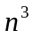 multiplications and 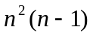additions. A more complex example is multiplication of two polynomials of degree ; this can be done with about 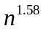multiplications, or better.
The fact that an algorithm is polynomial isn’t necessarily a sign that no more study is needed; polynomials grow plenty fast, and many polynomial algorithms become intractable for reasonably sized problems. Problems without polynomial algorithms, however, are usually the ones labeled intractable since their growth in complexity is far worse than polynomial.
For example, consider finding the largest prime number evenly divisible into a given input. The best algorithm involves successively dividing the input by smaller and smaller numbers until no remainder is obtained. This divisor must then be inspected to see if it is a prime by dividing it by smaller and smaller numbers and verifying no remainder. For n input digits, the number of divisors to be considered is 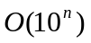, which is exponential in n, not polynomial.
Another example is the famous Traveling Salesperson problem. In this problem (which has many equally problematic variations), a hypothetical sales person must find the shortest tour of n points in a plane. Years of research suggest that there is no algorithm guaranteed to find the best solution except exhaustive search through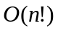 possible tours.

P and NP
It is customary to define the world of “reasonable” problems as P:
P: The set of all problems that can be solved by deterministic algorithms in polynomial time
Unfortunately, many problems do not seem to have polynomial time algorithms.
Many problems would be solvable in polynomial time, however, if we had a non-deterministic machine. The logic for developing these solutions is:
- (Magically) guess the correct solution
- Verify that this solution is correct and optimal
Problems for which the verification step can be performed in polynomial time are called nondeterministic polynomial (NP):
NP: The set of all problems that can be solved by nondeterministic algorithms in polynomial time
It is clear that any problem in P is also in NP.
The classic example of a problem in NP is satisfiability. This problem starts with a Boolean equation of the form:
Satisfiability asks if there is an assignment of logical values to the set of n 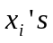such that the equation is true. The standard solution is to proceed with generation of all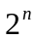input combinations until either a solution is found, or all possibilities have been exhausted.
It is interesting to note that no one has ever been able to prove that any problem is in NP but not in P; this suggests that there may be a polynomial time algorithm lurking out there that solves satisfiability. The theory of NP-completeness makes this extremely unlikely, however.

NP-completeness
The likelihood of finding a “good” deterministic algorithm for a problem in NP is extremely small. S.A. Cook proved that satisfiability is NP-complete in 1971. This means that if a polynomial time algorithm can be found to solve satisfiability, then all problems in NP can be solved in polynomial time. This very strong result forms the core motivation for the abandonment of the search for better algorithms and the development instead of different computing methodologies. The following problems, along with thousands of others, have been shown to be NP-complete:
PARTITION: Given a set of integers, can they be divided into two sets whose sum is equal?
INTEGER LINEAR PROGRAMMING: Given a linear program, is there a solution in integers?
MULTIPROCESSOR SCHEDULING: Given a deadline and a set of tasks of varying length to be performed on two identical processors, can the tasks be arranged so that the deadline is met?
VERTEX COVER: Given a graph and an integer N, is there a set of fewer than N vertices which touches all the edges?

Solving NP-complete Problems
The area of Artificial Intelligence runs into NP-complete problems almost continuously. Often, a clever attack can allow solutions to at least moderate instances of NP-complete problems. These approaches fall into three categories:
- Approximation Algorithms. Polynomial algorithms can often be developed which can be shown to generate suboptimal solutions to a specific problem. The discovery of such algorithms is very time-consuming, and their applicability is typically limited to very specific problems.
- Average Case Treatment. By ignoring worst-case situations, polynomial algorithms can sometimes be found which usually generate optimal solutions. Again, this technique tends to be extremely application-specific, and the possibility of occasionally finding no solution at all is quite troubling.
- Efficient Exponential Algorithms. This requires the development of “branch-and-bound” algorithms which attempt to traverse the exponential tree as efficiently as possible.
This third area has given rise to forward checking, backtracking, iterative deepening, A* search IDA* search, and a very rich array of techniques, tricks, and variations on themes which vastly increase the size of problems that can be approached with traditional sequential computers. However, these techniques merely postpone the inevitable, since a large enough instance of a exponential problem cannot be solved in reasonable time.
Unfortunately, the kinds of problems a cognitive computer would be expected to solve are almost universally exponential!

Thinking Algorithmically; 8 and 15 Puzzles
Almost any problem that requires many sequential steps for solution enlarges in complexity faster than any polynomial. This means that large instances of such problems have solution spaces that are unfathomably large.
For illustrative purposes, let’s consider the problem of solving an 8-puzzle. This is a toy puzzle in which eight tiles are set in a 3x3 grid in such a way that tiles adjacent to the one blank may be slid into the position of the blank. The goal is to get the eight numbered tiles into some desired state. Consider the following goal:
1 | 2 | 3
8 |  | 4
7 | 6 | 5
With the following initial state:
5 | 4 | 7
1 | 2 | 3
6 | 8

The first move must be either tile 3 or tile 8. This can be called this Up or Left by considering the move to be the movement of the space either into the square occupied by tile 3 or tile 8, respectively. After this, three moves are possible from either new location. A move tree can be built up as follows:
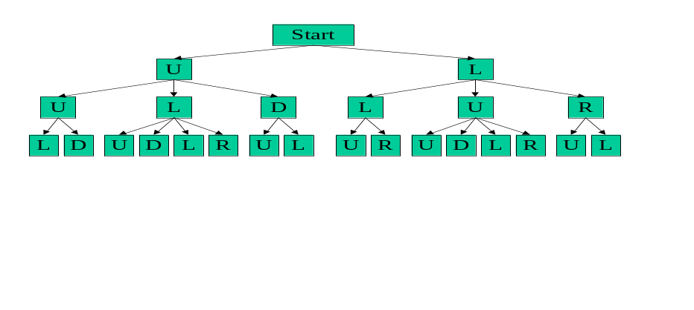
Figure 1: 8-Puzzle Search Tree
Even in a simple game like the 8 Puzzle, the variety of possible moves is enormous. Since two moves are possible when the blank is in any of the four corners, and three moves are possible from each of the side midpoints, and four moves from the center position, the average number of possible moves is 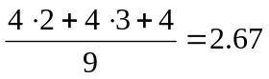. Thus, a puzzle which takes 20 moves to solve has a tree with 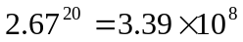paths. The actual number of starting situations is easy to compute. The first position can be occupied by any of 9 tiles, including the blank. The second position can be occupied by any of the 8 remaining tiles. Continuing in like fashion, the total number of 8-Puzzle situations is seen to be 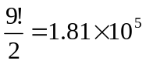. The division by 2 is required to preserve parity; since each move really is an interchange of the blank with a numbered tile, it is impossible to move an odd number of tiles! Thus, a desired final state may only be reached from ½ of the number of possible starting configurations.
A nice simplification arises from realizing that it is useless to move up followed by down, or left followed by right, since these move combinations simply return the puzzle to an earlier state. More sophisticated search algorithms attempt to extend this notion further by cataloging ALL previously visited states, and insuring that no state is ever visited twice. The relative expense of this operation makes its usefulness extremely situation-dependent.
At any rate, eliminating direct reversal cuts the tree branching factor from 2.67 to 1.67, such that a 20-move solution now requires investigation of only 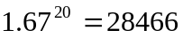 paths.
The situation rapidly deteriorates with scaling, however. A more complex version of the 8-Puzzle is the 15-Puzzle, in which 15 numbered tiles are set in a 4x4 grid. The rules are the same, although the complexity of the puzzle is much greater than is that of the 8-Puzzle. The following goal state will be used to allow analysis of the 15-Puzzle as a simple extension (although with extreme consequences) of the 8-Puzzle.
9 | 10 | 11 | 12
13 | 1 | 2 | 3
14 | 8 |  | 4
15 | 7 | 6 | 5

A similar analysis to that performed on the 8-Puzzle yields staggering results. Since two moves are possible when the blank is in any of the four corners, and three moves are possible from each of two side midpoints, and four moves are possible from each of four the center position, the average number of possible moves is 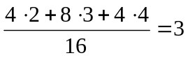. Also, 15-Puzzles take more moves to solve than 8-Puzzles. A 90 move solution, which is not atypical, would have a tree with 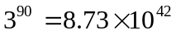paths. The actual number of starting situations is 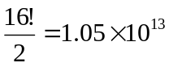. The division by 2 is again required to preserve parity.
Clever search methodologies use “heuristics,” or rules-of-thumb, and clever branch-and-bound technologies to try to search as little of this tree as possible.
The 8- and 15-puzzles will be used for development later on. They represent problems that are too difficult for traditional computerized search. In additional, it is doubtful that any human being can solve an 8- of 15-puzzle by inspection (in non-trivial instances). However, intelligence does require solution “by inspection” of less complex problems. This is a problem any human would find easy to solve.

Thinking: The Garage Door Problem
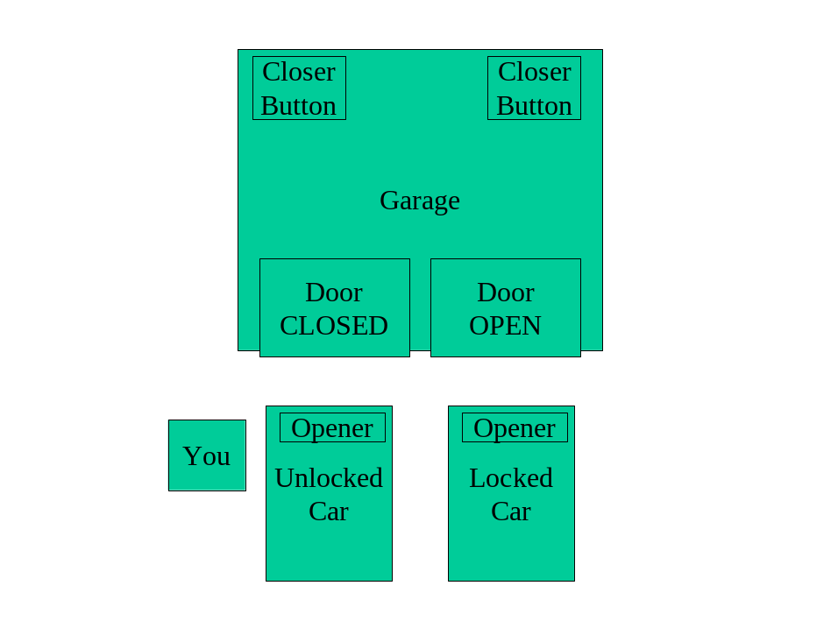
Figure 2: The Garage Door Problem
Two cars are in the driveway, each in front of its own garage door. Each car contains its own garage door opener clipped to the visor. There are two pushbuttons inside the garage allowing either garage door to be opened or closed from inside.
You are standing next to the car on the left. The garage door on the right is open. The car on the right is locked, and you do not have the key. Close both garage doors before you back out of the driveway in the unlocked car and go to work.
The solution, once the problem is understood, is obvious. Discerning this solution requires forward simulation of possibilities and consequences in exactly the same way that discerning an 8-puzzle solution requires forward simulation through the tree. In the case of the garage door problem (which I have had to personally develop real-time solutions for), the solution seemed trivial in spite of poor definition and an enormous branching factor. There are literally hundreds of actions that one could take at each turn, and yet we seem to not even consider them. For example, locking the unlocked car does not appear as part of a typical human solution. How do we know to avoid this action?

Generalization to Games
The problems considered above are puzzles. The difference between “puzzles” and “games” is that in a puzzle there is only one brain involved, while in a game there are two or more. Games imply the notion of adversaries. Many people find puzzles “frustrating,” and games “challenging.” This is just a reflection of our survival strategy.
Games can be roughly partitioned into two major categories:
- Games in which chance plays no role
- Games in which chance plays a role
Games in which chance plays a role typically require dice, shuffled cards, or some sort of randomizing device to inject the uncontrolled element of “chance” into the game.
Game play introduces a new element into “thinking,” since successful game play requires prediction of the actions of an opponent. The most likely way this is handled is to “put one in the place of” the other player, and try to select their countering moves based on an expectation of their style of play. This activity in itself may be cast as a puzzle, as will be shown later on.
The element of chance simply increases the branching factor at each level of the game tree, and requires the addition of a probabilistic element in helping to choose the “best” move. In real games, as in real puzzles, there is almost never an “optimal” move, since the definition of optimality is so dependent on individual assumptions and preferences which cannot be proven inferior or superior.

Evaluating Thinking Machines Using Puzzles and Games
A computing architecture capable of solving 8-puzzles should be able to do a good job on the garage door problem, too, as long as the architecture is general-purpose and has no specificity to the 8-puzzle problem itself.
Focusing on puzzles and games seems a reasonable way to explore cognitive behavior. If we can build a general-purpose machine that is exceptionally good at solving arbitrary puzzles and playing arbitrary games, we have come a long way in the development of synthetic thought.
Most people like puzzles and games. The puzzles and games that we play are invented in other human brains. These “brain teasers” reveal a great deal about the internal structure of these higher brain functions.
Humans easily tire of children’s games like tic-tac-toe, since it doesn’t take long for a human to become adept at playing to a draw every time. In fact, two marginally intelligent humans can play tic-tac-toe for a thousand years with every game running to a draw.
Consider that the situation is entirely different in Chess. Chess is “hard,” but millions of people play it passably well, and large numbers play it extremely well. A special-purpose computer plays it best.
If there are “easy” games, like tic-tac-toe, and “hard” games, like chess, are there “impossible” games? Not too many exist, since humans don’t invent games that are too hard, because we would be embarrassed by our inability to play. An example of a game that is probably too hard for humans to play is Morph Chess. In Morph Chess, imagine that each piece is identical, but has rules of movement that are dependent upon the last three game square the piece visited. Furthermore, all pieces have the same color, and it is the job of each opponent to remember which pieces are theirs. Our brains are just not “smart” enough to play this game.
Smartness, in this sense, seems more to be a hardware limitation, not an architectural or software limitation. In fact, a larger brain would undoubtedly be able to play Morph Chess quite competently.

A Learning Model for Puzzles and Games
This learning model does not attempt to describe how learning takes place; here, it is more concerned with what must be learned.
Humans don’t seem to learn via back propagation-like techniques. It would be quite difficult for someone to learn how to play chess by simply watching, say, 100 games played by grand masters. The intricacies of knights jumping other pieces, the allowed movement of each piece, and special cases like castling and queening would be hard enough to learn. Any hope at all of developing a strategy based on an analysis of only 100 games would be doomed to infantile play.
So how do humans learn? This is a difficult question, since learning goes on at so many levels in human thought. For our purposes, we restrict the question to “How does a human learn to play a game?”
This is an easier question to answer. We have all taught someone how to play a game.
An interview of my 5 and 11-year old children revealed the entire answer. To play a game, we need to know what the game looks like, what the rules are, and what the object is. Call these Situation, Rules, and Goal. This will be referred to as the SRG Game Description.

Situation
The Situation of a game is the board, pieces, or other symbology arranged to represent a game situation. In chess, this involves understanding the 8x8 grid square of the board, and being able to recognize each piece, and being able to differentiate between white pieces and black pieces. In an 8 Puzzle, this involves being able to read the symbols on the tiles, and seeing their respective positioning relative to one another.

Rules
Every game has rules. In chess, the rules consist primarily of rules governing how each piece may move, how play alternates, and a couple of special case rules, like castling and queening. In 8 Puzzles, the rules include just the restriction of motion to tiles adjacent to the blank.

Goal
The goal is the solution of the puzzle or victory in the game. In chess, this is checkmate, with a strong warning about the dangers of stalemate. In the 8 Puzzle, it is simply a picture of the desired location for the 8 tiles in the final position.
It seems that armed with an understanding of these three areas, humans can begin solving a puzzle or playing a game immediately. That is:
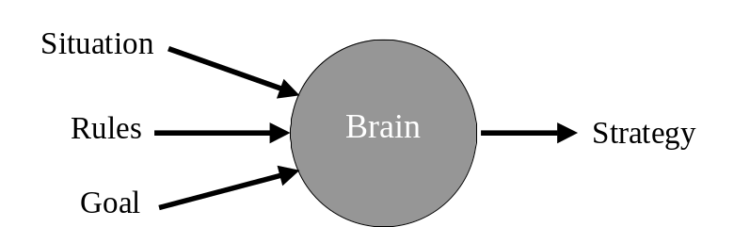
Figure 3: Synthesizing Strategy
Is there hardware in the brain that synthesizes strategy from an SRG description of a puzzle or game? It seems inescapable. But what is the nature of that hardware?

Neural Network Research
We have a fairly good understanding of how some neurons operate, although many details are elusive. Furthermore, there has been extensive experimentation with small networks specifically “trained” to recognize or classify in simply situations.
Unfortunately, most computer science research uses a neuron model that is so trivialized as to be almost useless. More of the details on real neuron modeling will be presented in the next section.
But building a neural network involves not only selecting the type and number of neurons. It also requires the placement of interconnections and personalities of synaptic boundaries.
The literature is full of ideas and variations on a basic theme; start with an arbitrary neural network, apply known inputs, compare to expected outputs, and try to "nudge” the network weights to decrease the error between expected and received output. These techniques are grouped under many categories, but can be thought of generically as “back propagation” for these purposes.
Much research has been done in the area of tuning simulated neural network weights to perform various pattern classification functions. In supervised learning, a set of input patterns is applied to a proposed network in conjunction with a set of desired outputs. The difference between the actual network output and the desired network output is propagated backward through the network in such a way as to suggest modifications to the network weights.
In practice, many factors influence how quickly, and how well, the network develops the ability to generate all of the expected responses. Many scenarios set up oscillations that prevent the network weights form ever reaching optimal values.
These experiments generally rely on small, largely feed forward networks. Extensive networks, with many simulated neurons or many interconnections, or extensive feedback paths quickly overwhelm standard simulation hardware. Networks with more than a hundred or so neurons become very unwieldy, and are exceptionally slow to train.
If humans learned this way, it seems that it might have taken from the dawn of time until now for a single human to learn to walk and chew gum at the same time. Gerald Edelman, Nobel laureate in physiology and medicine, has said
Whatever the mind is, it is an ensemble property. That is to say it is a property of a collection of things, a very large collection of things, just as, for example, temperature is an ensemble property of molecules.
Imagine trying to understand the property of temperature by the study of a single molecule. It would a futile as trying to deduce computer architecture by studying an AND gate, or worse, a single transistor. When we think in terms of individual neurons, or even small clusters of neurons, we make the task of deducing overall brain operation extremely difficult.

Background in Neurophysiology
This section develops a focused look at neurophysiological research on neurons, the brain, and some sensory data processing.

The Neuron
This section develops background material on the biological neuron. This material forms the basis for many of the hypotheses used to develop the new computing architecture proposed later in this dissertation.
It has been estimated that there are about 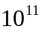 neurons in the human brain. Since many have interconnects that are tens of centimeters long, and since their interconnectedness is so prolific, it is likely that no brain cell is more than six or seven brain cells away from any other.
The whole brain is composed of more like 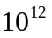 cells, with the other 90% that are not neurons being composed of insulting cells, blood and neurotransmitter transport networks, and perhaps a communications network or two. The exact behavior of these other 90% of the brain cells seems simple, but might not be.
An individual neuron might have several thousand axons from other cells inputting signals into it; a general rule is that the receipt of just a few messages from other neurons is unlikely to make a neuron fire. However, different neurons get unequal weights. Certainly, axons connecting closer to the cell body have a better chance of making the neuron fire, much like the loud voices at the front of the room count for more “votes” in a voice vote. Cairns-Smith, for this reason, introduces the (still oversimplified) idea of the “Union Neuron,” in which the neuron takes a voice vote to decide whether to fire.
It is important to remain focused on the processing aspect of the brain for two reasons:
- Evidence is accumulating that suggests that memory operates in the brain at a level lower than the neuron.
- The development of a digital computational model of the brain only requires understanding of data access and processing; computer memory technology already far exceeds, in capacity and speed, the memory capabilities of any human.
It is tempting to think of the neuron as an inquiry/response kind of system: we apply inputs, wait, and then receive (possibly) an output. But there are many kinds of neurons, and each behaves differently. Many spontaneously active neurons have been found in both vertebrates and invertebrates, prompting physiologists to give them names like bursters and oscillators.
Much of our understanding of individual neuronal activity is due to the Nobel Prize-winning work of Alan Hodgekin and Andrew Huxley, two English neurophysiologists who in 1939 developed a wire electrode fine enough to be threaded into a squid’s largest axon, opening up the possibility for study of neuron response to synthetic stimuli. Their work, and the research their invention permitted others to perform, triggered development of a view of the neuron as a summing circuit, which somehow prepared a weighted sum of all of its inputs, and then fired, or did not fire, based upon the total sum.
This view of the neuron is woefully oversimplified, however. The electrical behavior of the neuron is based upon its ability to build up, and discharge, electric potential, a capability provided by the selective, controlled passage of sodium and chloride ions through various parts of the neuron membrane. Hodgekin and Huxley only hypothesized the existence of one trans-membrane channel for each ion, sort of a charging channel, and a discharging channel.
Since 1939, however, researchers have discovered at least ten additional ionic channel types, and most agree that many more await discovery. The details of these individual channels are not important to this dissertation. Their effect, however, is extraordinary. Says Allport:
They are indeed responsible for the fact that one neuron is a spontaneously bursting cell that produces rhythmic bursts of action potentials without any synaptic input at all, while another is a silent cell that requires a long, slow stimulus before it will fire. They are also the reason that cells react to an injection of the same amount of positive current in quite different ways: one neuron might respond with a long train of action potentials, while a second shows no response at all; a third cell might bark – or fire - once, then remain silent.
Up through the 1960s, understanding the brain was thought to be a wiring game; if you could map out which neurons were connected to a particular neuron, you could deduce the function of the brain. The continued discovery of new, complex, and ever-more clever ionic channels in neurons began to make the emphasis seem like it should be more on the neuron, and less on the interconnects.
Gerald Fischbach, former president of the Society for Neuroscience, says, “One of the great embarrassments in neurobiology is that we don’t know whether there are thousands, millions, or billions of electrophysiologically distinct neurons.”
From a digital electronic standpoint, it is easy to think of the neuron as a generic logic gate. We have many different kinds of specific gates, with different properties, AND, OR, INVERT, One-shots, oscillators, flip-flops, and so forth. We can have edge-sensitive inputs, as well as open-collector or high-impedance outputs. It appears that by building the right ionic channels into a neuron, we could construct a biological version of almost any digital logic gate in common practical use. Further investigation of these properties is not required for the purpose of this research.
There are some interesting developments in the area of neural interconnection, as well. Neural interconnections occur at synapses, locations where individual neurons come into close physical contact, but do not really touch. The transfer of information is carried out through the release of chemical neurotransmitters from one side of the synapse, and their attachment to receptors on the receiving neuron.
In the 1970s, it was thought there might be three or four such chemical messengers. Today, researchers suspect the existence of hundreds, each of which has special properties. Some remain in effect for as little as 10 mS, while others can linger for minutes, hours, or even days. Some are inhibitory, some are excitatory, and others seem to have a regional effect over any number of cells, as long as they have the right receptors. So much for wiring diagrams.

A thorough literature review on the state-of-the-art in the physiology of neurons and their interconnection would occupy volumes. Suffice it to say for now that there are many different kinds of neurons, much as there are many different kinds of gates in a computer system. Furthermore, interconnection between elements follows most of the rules of modern day digital design: the highest-speed connections must travel short distances, while lower speed connections can travel larger distances. Furthermore, when some special connection is needed from any point to any other, there is almost always a way to make the connection.

The Brain
A machine is explained in terms of physics and chemistry plus (at least) an engineer. An organism is described in terms of physics and chemistry plus (at least) evolution through natural selection.
A.G. Cairns-Smith
Modern humans are “the dazed survivors of a continuous, 5-million-year habit of lethal aggression.” This categorization is not intended as a springboard for social commentary; rather it reveals a way of exploring and analyzing the mind that may be more in line with the actual design principles that were in play during its evolution (at least, up to this point).
Much of the development of the human mind was required to insure survival during millions of years of evolution and savage competition. Our present behavior and “intellectual” pursuits (like the development of this dissertation, or even just reading the Sunday paper) are so far removed from 99.991% of our developmental history that it would seem naïve to use our present behavior as a case for describing the purpose for the brain.
That we can engage at all in more “intellectual” pursuits with the hardware at our disposal is a tribute to the generality and extensibility of the system. This fact does, not, however, likely indicate that research on how modern humans think, from a behavioral standpoint, really reveals much about how the brain really works.
The neuron is not so much different from the other cells in our bodies. The only really new idea is “long distance telegraphy”, the use of action potentials to rapidly transmit information from one place to another. This form of communication is only in addition to, and not in place of, the standard chemical communications that constantly occurs between cells.
The following evolutionary discourse is largely due to Dr. Graham Cairns-Smith in Evolving the Mind (1996). In this book, Dr. Cairns-Smith provides an illuminating, insightful, readable and altogether enjoyable look at the physics and biology of human brain evolution.
The human brain is a highly evolved organ. This is to say that the brain is built from successively newer structures, and included ancient places, and modified ancient places, as well as very new places.
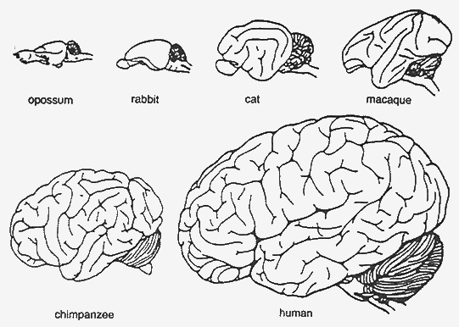
Figure 4: Respective Sizes of Mammalian Brains
Figure from Cairns-Smith (1996), p. 127
The figure above is a scale drawing of mammalian brains. Human intelligence is an enhancement on opossum intelligence, not something special or different in major ways. The most major difference between a chimpanzee brain and a human brain, is simply size. The other differences tend to be evolutionary, rather than revolutionary.
It seems like it should be easy to figure out how an opossum thinks. If we can, we can probably determine how humans think, too.
Most of the recent development attributable to the development of higher intelligence has happened in the huge hemispheres of the cerebrum that occupy most of the skull. The cerebral cortex, which most call simply the cortex, is the familiar, convoluted outer shell of the cerebrum. The neocortex is the newest part of the cortex, and is widely believed to be the seat of higher intelligence.
Basic reflexive actions can be handled in simpler animals with just the “auto-pilot” type circuitry found in a ganglion. Over time, ganglia expanded into a rudimentary spinal cord. Then the brain started as a swelling at the top of this simple cord, eventually dividing into a hindbrain, a midbrain, and a forebrain.
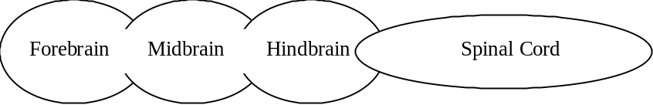
Figure 5: A Brain in Three Parts
The forebrain later subdivided into two districts, to give a set of five regions:
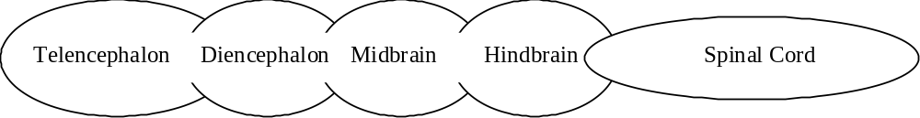
Figure 6: A Brain In Five Parts
Finally, a more complete structure evolved:
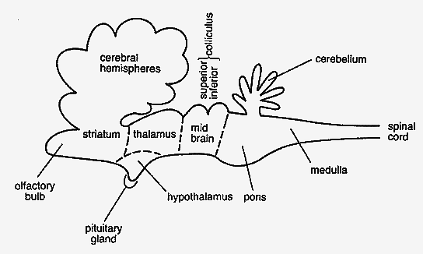
Figure 7: A More Complete Brain Schematic
from Cairns-Smith (1996), p. 129
From the bottom up:
Spinal Cord. Bilaterally symmetrical, and segmented, in that bundles of nerve connections repeat along its length. Here, the white matter (connections) is on the outside, and the gray matter (processors) is on the inside. Most processing here is restricted to tight closed-loop reflexes, although the more intricate parts of balance necessary for walking are automatically handled here as well. We couldn’t walk if our motor updates were only 3 or 4 per second. Also, the spinal chord processors insure that our finger is pulled away from the candle long before we register any pain.
Medulla. Remnants of the hindbrain are here. This is where most upper sensory and control connections are made, including hearing, control of face and eye muscles, and others. More importantly, control of the major organs, including heart and lungs, takes place here. This is a background process that is controlled and monitored perfectly well, even after massive damage to the cerebral hemispheres (permitting the existence of so-called vegetative state; someone who is alive but “brain-dead”).
Pons. A bridge-like swelling that may be thought of as a giant junction box, like the Main Distribution Frame in a telephone company central office.
Cerebellum. This is the first area of truly higher order processing. It may be thought of as the first draft of the cerebral hemispheres. This is clever motor functions (riding a bike, juggling) are controlled. This may be thought of as the place where unconscious activity or expertise will be controlled.
Inferior colliculus. Now we’re up to the midbrain, in a region concerned mostly with processing of auditory information.
Superior colliculus. Some basic vision functions, such as lower order image processing and coordination of eye control.
Thalamus. Now we’ve reached the diencephalon, the lower half of the forebrain. This critical, fist-like structure is at the heart of brain structure, surrounded by the higher cerebral hemispheres, and heavily connected with them. This may be the central controller, or just a junction box, or something in between. The much smaller, but vital hypothalamus may play a key role here as well.
Telencephalon. This is the end of the line, at least for a few million more years. This region is dominated by the enormous cerebral hemispheres.
Cerebral Cortex. Now, the gray matter is on the outside, with the wiring on the inside. The cortex is a continuous sheet of cells 2 – 3 mm thick, and generally made up of six sub-layers of a large variety of different kinds of neurons.
Some cells, such as ‘chandelier’ cells and ‘basket’ cells make local connections, while pyramidal cells have long axons making connections elsewhere. Pyramidal cells in the upper layers of the cortex connect to lower layers below, while pyramidal cells in the lower cortex make connections to places outside the cortex, such as down toward the thalamus.
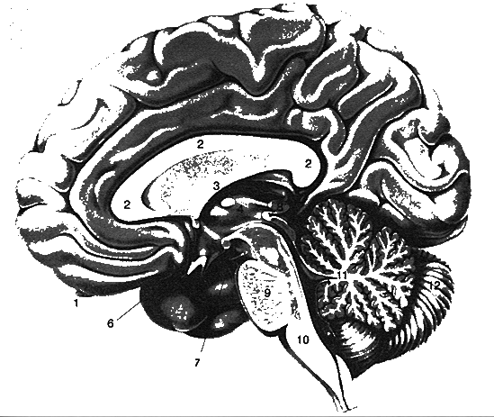
Figure 8: Brain Structure
1 Olfactory Bulb
2 Corpous Callosum
3 Formix
4 Thalamus
5 Hypothalamus
6 Optic chiasma
7 Oculomotor nerve
8 Pineal body
9 Pons
10 Medulla oblongata
11 Vermis of cerebellum
12 Right hemisphere of cerebellum
Figure from Cairns-Smith (1996) p. 133
The Cortex is where the action is, at least from a processing standpoint. The cortex is divided up into several regions, called the frontal, parietal, occipital, and temporal lobes.
The original cortex is small and obscured in the modern brain. The preponderance of the human cortex is neocortex, or the new extension to the cortex. It is exactly these new structures that we must look at to see where the difference between human thought and lower animal thought is built.
The general structure of the neocortex is as described early, with a general six-layered architecture organized into macrocells. But the cells themselves vary. And the interconnect methodology varies, which prompted K. Brodman to make much more detailed maps in 1914. These maps are shown below.
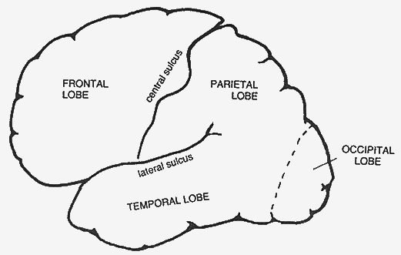
Figure 9: Rough Cortical Map,
From Cairns-Smith (1996), p. 138
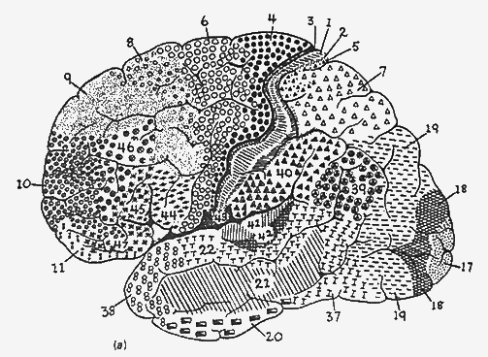
Figure 10: More Detailed Cortical Map
From Cairns-Smith (1996), p. 139
These maps indicate a richness and diversity in the processing hardware architectures devoted to different activities. In fact, though the architecture of the macrocells seems consistent in some generic way throughout the neocortex, the specialized regions are definitely wired differently, composed of different flavors of neurons, and connected to different I/O. A decent, but oversimplified, map of these regions is shown below.
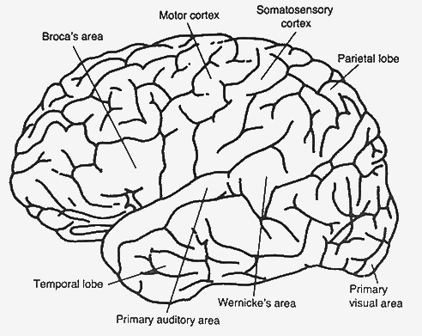
Figure 11: Some Intemediate Cortical Detail
Figure from Cairns-Smith (1996), p. 140
The visual and auditory areas are clearly shown. The Somatosensory cortex is a region onto which are mapped the control and sense connections to individual body parts. Next forward is the motor cortex, a region onto which are mapped everything from our toes to our lips. Especially dexterous regions, like the hands and the facial muscles, have a much larger region of motor cortex dedicated to them.
The sensory and motor portions of the neocortex consume about 25% of the device. Forward of the motor cortex is the premotor cortex, which shows signs of intense activity just prior to our initiating complex actions. It is though that planning of complex motions is carried out here. The “planning” nature of the neocortex seems to increase as we move forward further; we find regions neurobiologist call association areas, in which associations, analysis, and synthesis presumably occur.
Some other interesting portions of the neocortex include a region underneath the temporal lobe specifically involved in face recognition. From an evolutionary perspective, face recognition is pretty important to survival and procreation, so it makes sense we have a specialized region for it.
Other regions of special interest are Broca’s place and Wernicke’s place. These regions are associated with speech generation. Broca’s place is concerned with grammar; with a damaged Broca’s place, you might know what you want to say, but have trouble assembling words into a coherent and correctly constructed sentence.
Wernicke’s area is concerned more with global meaning; if you have a damaged Wernicke’s area, you might speak grammatically correct, but nonsensical, sentences.
A more stylized, but still anatomically correct schematic drawing of the neocortical connections (with the exception of the frontal lobe structures for analysis and planning) as shown below.
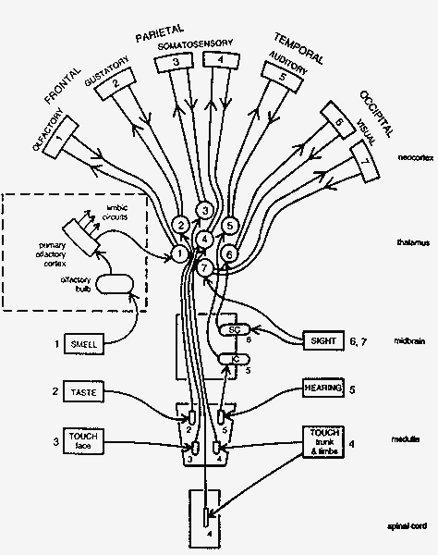
Figure 12: Thalamic Input Preprocessing
Figure from Cairns-Smith (1996), p. 159
From an engineering perspective, it is easy to imagine a computation system with similar regions in it, each designed specifically for a similar subtask. A remaining question is that of interconnect; indeed, in most advanced computer architectures (and it is correct to consider the brain an advanced computer architecture) the wiring and interconnect scheme is the most critical, and often the speed-limiting, factor.
So how is the cortex wired? The impression of neurobiologists is that the cortex is almost fully interconnected; ribbons and bundles of axons are connecting almost every region to every other region.
The wiring is highly organized and compact. The atlas figure below shows how some major bundles are routed in one hemisphere.
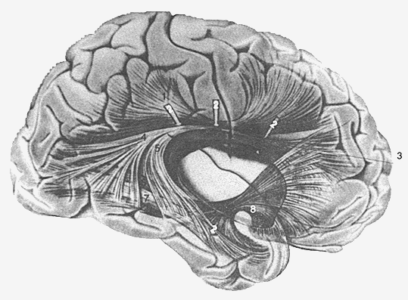
Figure 13: Internal Brain Wiring Pathways
Figure from Cairns-Smith (1996), p. 144
The star of the cortex-cortex (corticocortical) connections is the corpus callosum, a massive bundle of interconnects between the two hemispheres. Many “split-brain” experiments have been carried out on patients whose corpus callosum has been surgically severed, primarily in the treatment of severe epilepsy. Epilepsy triggers severe “seizures,” episodes in which the brain engages in uncontrolled feedback. Severing the corpus callosum is one (extreme) way to reduce the possibility of feedback loops.
In addition to the corticocortical interconnections, there are many input/ouput connections, which neurobiologists refer to as “projections.” Primary among these is the corona radiata which connects the cortex to central structures which can be thought of as “downtown brain.”
The center of the brain contains complex, ancient structures, grouped primarily due to their spatial locality under the heading limbic system. The limbic system includes the hippocampus, widely held to play a large role in long term memory.
It seems the hippocampus was once a more central structure, actually larger than the neocortex in the shark brain, a very ancient design. In mammals, even as primitive as the rat, the neocortex already dwarfs the hippocampus. These changes are shown schematically in the figure below.
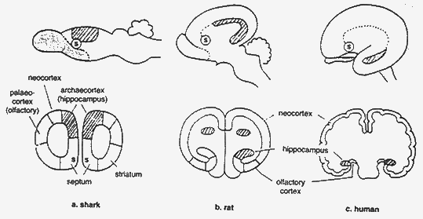
Figure 14: Neocortex Explosion in Humans
Figure from Cairns-Smith (1996), p. 146
In this figure, it is also possible to see the migration of the septum, another limbic structure, although in humans it maintains its tight connection with the hippocampus through an extended wiring interconnect known as the fornix.
A number of other ancient, complex, and mysterious structures reside in downtown brain, as shown in the figure below. The exact operation of each remains in dispute, although a great deal is known about the behavior of patients who are missing one or more of the structures.
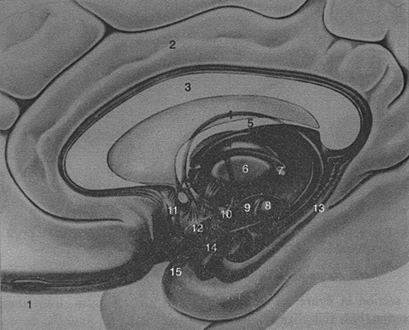
Figure 15: Downtown Brain
Figure from Cairns-Smith (1996), p. 148

Brain Signal Input Conditioning
This brief introduction is focused primarily on the processing architecture of the brain, but input signal conditioning undoubtedly plays an enormous role in shaping the processor designs. As a means of introducing this kind of signal conditioning, let’s look briefly at the input processing of the human’s most complex sensory system; the eyes.
The human retina, located at the rear of each eye, is composed of about 100 million rods and cones, cells which respond to light in three different color bands.
We commonly think of these bands as red, green, and blue, but they actual are closer to 420, 530, and 560 nm. Furthermore, the response bands are not very sharp; to perceive the color red, for example, we must compute and integrate signals from all different bands.
The 100 million rods and cones of each eye are reduced to about 1 million nerve signals on the way to the brain. First, they reach the optic chiasm, where they are redistributed. Then, they pass to the left and right lateral geniculate nuclei (LGN) of the thalamus. This wiring structure is shown below.
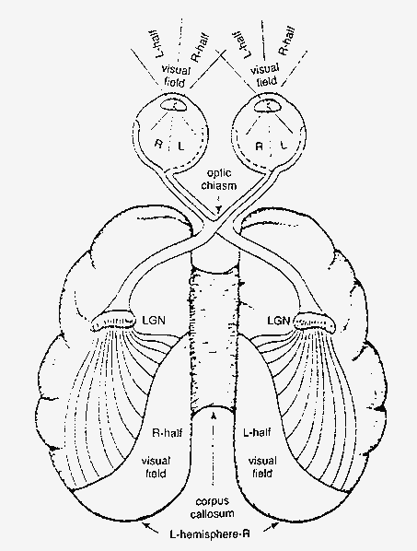
Figure 16: Optical Routing via LGN
Figure from Cairns-Smith (1996), p. 163
The LGN is a powerful filter bank, performing detailed processing and reprocessing of the vision signals. A structural detailed analysis of the LGN is shown below.
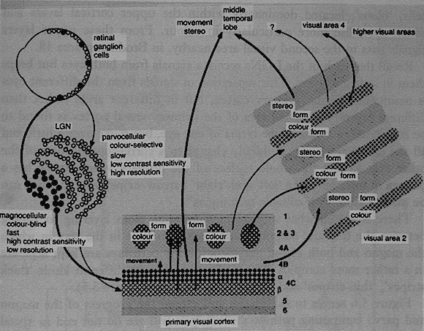
Figure 17: Detailed Map of LGN Interconnection
Figure from Cairns-Smith (1996), p. 165
This processing highlights motion, edges, angles, colors, and a variety of other features of interest before passing these multiple data representations on to the visual cortex. This arrangement of data makes the information particularly well suited to associative processing; that is, processing in which the feature of interest are not necessarily known a priori, and which only become recognized as the features of interest after analysis. A block diagram of this processing is presented below.
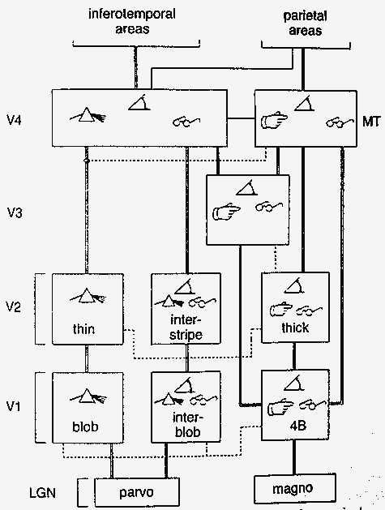
Figure 18: Approximate Visual Filter Bank
Figure from Cairns-Smith (1996), p. 167

Background in Cognitive Psychology
This section looks at more behavioral-oriented background from the realm of cognitive science.

Memory
Tulving, Working, …

Thinking
Strategy, etc.

A Model for Brain Operation
The brain exists, and it works extremely well. All neurological evidence and psychological research seems to point to the fact that the brain is a machine, admittedly extremely complex, and if it seems mysterious it is only due to our lack of understanding of it.
Understanding the nature of birds turned out to not be important to Orville and Wilbur Wright, who ignored legs, feathers, flapping wings, rear-mounted control surfaces (though these came back later), and a plethora of other physiological, chemical, and neurological information about birds in the construction of the first self-powered airplane.
Similarly, we can ignore a great deal of baggage of the mind in attempting to design new computing architectures. Some of this baggage would be:
- The power of self-repair. This is not important to use at this time. We can repair the machines ourselves.
- The capacity to reproduce. This is probably not recommended, even if we knew how to do it.
- Consumption with survival. A new system does not need to be able to defend itself to be intelligent and useful.
- Extreme motion control and dynamic control capability. Modern computer technology can perform closed-loop control far more accurately than biological systems. What has been missing is the real-time intelligence to specify what actions need to be performed to accomplish a task.
- Evolutionary baggage. Many brain structures (and related human behaviors) carry over from times lost. Reproducing evolutionary structures is not required in a design-from-scratch.
- The miracle of memory. Digital technology has this problem solved quite nicely. Digital memory accuracy, size, and access speed exceeds human capability in all areas except arbitrary associative retrieval, which can be an algorithm, not a storage technology.
- Core technology. The brain is chemically-powered. This makes sense for biological systems, but there is no evidence that chemical power is a requirement for duplicating brain intelligence.
However, many properties of the brain seem to represent core requirements, or at least key concepts in the understanding of its operation. These postulates are advanced below.

Cortex and Downtown as the Computing Machine
It has long been believed that the convolutions and folds of the cortex have something to do with intelligence, since they are most pronounced in the human brain, and become less and less pronounced as we examine the brains of simians and lower mammals. This strongly suggests that increasing the surface area of the cortex is somehow required for increased intelligence. The obvious way to increase cortex area is to simply increase head diameter. The reasons for not expanding head diameter are twofold:
- Big heads are very difficult to pass through the birth canal
- In increase in head radius of r increases cortex area as 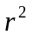, but increases wiring volume as 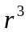; perhaps the area increase of the cortex is more valuable than is the wiring volume.
It is safe to assume that both factors play some role; however, natural selection has overcome numerous mechanical problems easily in the past. It is tempting to imagine the first Cray supercomputer, with processing boards huddled around a central wiring column to keep the interconnectedness high and the length of their connections short. The increase in cortex area through convolutions accomplishes the same wiring goals while allowing a vast increase in the area of the cortex.
As an aside, the cerebellum is organized much like the cortex, although with much tighter convolutions and less white matter.
It is interesting to pause for a moment and ask the question, “Why so much wiring?” The answer may have to due with programmability. The cerebellum is an ancient structure. It evolved long before humans were capable of performing what we today would consider to be intellectual tasks. It is special purpose, and is wired to perform very specific motion control and dexterity kinds of functions.
The other processing region of the brain, the cortex, must be much more configurable. It can play chess, solve problems, and analyze situations in an ever-changing, continuously variable way.
There does not appear to be “software” or “microcode” in the brain; that is, there is no central data store of program instructions that are uploaded into general-purpose hardware on demand to reprogram pieces of the system. This is a great architecture, but it does not appear to be part of brain design.
Instead, the brain seems much more of a hardwired computer. How does one make a hardwired computer dynamically reconfigurable?
One architecture would be to take a processing unit and hardwire it for several different tasks, adding a few extra control inputs that effectively disable the connections that are inappropriate for the computation currently desired. This approach has the disadvantage of dramatically increasing interconnect requirement, as well as computational unit fan-in. At the same time, though, it does make for a simple, robust, reconfigurable system based on the hardwired paradigm.
I was fortunate enough to have the opportunity to work with an older analog computer in the early 1980s as an undergraduate. Programming the system was accomplished by connecting integrators, differentiators, filters, and summers using patch cords. The programs I “wrote” with the cords were simple, but my machine always seemed to be covered with piles of patch cords. Some were connected, some were only connected at one end, as I figured out where they should go, and were some connected at one or both ends between unused circuit elements without effect as a result of being left over from the last “program.”
I saw a computer that was extremely neat, one day. My professor had set up a static demonstration, and had neatened up the patch cords, using as few as possible to make the circuit more understandable and compact. My machine could never look like that, it was constantly being set up for new and different problems.
The neat analog computer is like a circuit in the cerebellum, implementing a program developed through natural selection millions of years ago. This program won’t be changing any time soon. The cortex is more like my computer, though. Wires everywhere, a system in transition. In fact, several different programs could be set up simultaneously, and each independently activated by just moving one or two of the myriad circuit connections.
Hardwire computers can be made dynamically reconfigurable, but at the cost of enormous growth in simultaneous interconnect, only a tiny fraction of which is actually significant at any time.
In this way, we can think about the neuron with 10,000 inputs as a simple analog computer that can be called upon to perform many different tasks at any time, simply by setting up the right control signals to help it choose which inputs to examine and which to ignore.

Memory Divided in a Procedural/Declarative Arrangement
Cognitive psychology has proposed many models for human memory. The conscious vs. the unconscious memory……

Size is REALLY important
The size of the machine, that is the number of neurons and interconnects, is very important. A fly has about 10⁶ neurons. A human has more like 10¹¹. While it is true that flies have very impressive 3-D flight control capabilities, the computational region of interest for this research is much closer to the billion-neuron level than it is to the million-neuron level.
Looked at another way, the human cortex, flattened out, has roughly the area of four standard sheets of paper. A chimpanzee has one sheet of paper. A rat has a postage stamp. While researchers are impressed with the capabilities of chimpanzees and rats in the laboratory, a useful new computing machine needs to have intelligence at the four-page level, not the postage stamp level. If scalable (and the design must be scalable, at least to 4 pages), it would, of course, be interesting to try out a ten-page version.
The development of a powerful new computing architecture probably requires that the scale be enormous by modern parallel processing standards. This means that a practical system requires simple, low-level hardware processors to allow fabrication of millions of processors using digital logic techniques.

Size isn’t terribly significant
We don’t need to consider all 100 billion neurons as a single system. Over the last hundred years, an enormous volume of research has revealed many of the secrets of the architecture of the brain.
Enormous sections are devoted to sensor input and conditioning. These may be thought of as large feed-forward clusters that reduce noise, correlate, and develop computed results from raw sensor data. For instance, while there are approximately 180 million sensor neurons (rods and cones) in each human retina, only about one million ganglion axons enter each optic nerve. These 1 million inputs are further reduced in the LGN to provide information in various formats and forms. Raw sensor data provides light intensity data in three different overlapping wavelength regions, while the actual data presented to the visual cortex includes orientation of edges, edge location, movement vectors, and color correlation. These sections of the brain are largely feed-forward logic, which is well understood, but still consumes a huge number of neurons.
Similarly, the brain has output conditioning and sequencing sections that operate in a largely feed-forward manner from the brain toward the muscle actuators. These circuits provide constant force capabilities, for example, by directly interfacing force sensors in the muscles back into the force generation signal. In this way, the brain need only generate a “maintain force xyz” command, and the muscle control system will provide the closed loop control system necessary to maintain this force without (as much) additional thought.
The clever part of the brain lies in the cortex, which with about 1 million similar processors of 1000-2000 neurons each, is easier to attempt to understand.

Data Storage and Data Processing are Separate
It is reasonable to assume that the storage of knowledge and the application of knowledge to solve a problem (cognition) are handled differently in the brain. Consider that it is possible for one to be “quick-witted” without knowing the slightest thing about a huge variety of topics. In addition, it is possible for one to be a “walking encyclopedia” of facts regarding a plethora of topics and yet to be utterly incapable of applying any of the knowledge in a practical way. This concept of memory vs. processing is familiar to traditional computer design, and will be assumed henceforth.

Many general-purpose CPUs give the most flexible design
The human cortex is a layer of generally six layers of neurons covering most of the outer surface of the brain to a depth of 2-3mm. This is the “gray matter,” know by neurologists and biologists alike to be the locus of the conscious processing units in the brain. The inside of the brain (the “white matter”) is mostly wiring.
The layers of the cortex contain a variety of cells known in neurological circles as chandeliers, basket cells, pyramidal cells, and so forth. The key to the differences between these cells is unclear, but some cells have local wiring, and some connect far, far away.
The quantity of neurons in the cortex are most developed in humans; indeed, mammalian, and ultimately human, brains evolved ever more convoluted surface contours to increase the area of this cortex region.
The neurons of the cortex are further organized into macrocells, cylindrical groups of 1000-10,000 neurons and 0.5 mm or so in diameter. A human has perhaps one million of these macrocells spread out over the cortex. Some are known to be associated with visual processing. Some to be associated with hearing, or speech. Some to be associated with complex movements and hand-eye coordination. (More coarse motor control is handled in the evolutionarily ancient cerebellum, a processing site shared by much lower forms of life.) In addition, the area of the brain associated with planning and strategy lives in the cortex, mostly in the frontal lobe.
The interesting feature of the cortex is that the processing macrocells, while associated with different types of cognitive activity, seem to have a somewhat uniform architecture. That is, there seems to be a processing macrocell in the cortex that is capable of performing a variety of cognitive tasks. The only reason for the localization of certain tasks to certain regions seems to be the choice of what inputs and outputs happen to be connected to the macrocells.

Wiring dictates behavior
The macrocells look like some sort of hardwired computer. This is actually possible since the typical neuron may have

Programmable elements can simulate wiring
That the axons interconnecting different regions of the neocortex are organized into ribbons and bundles may be hugely significant

A Trial Design
Given the state of computer science, digital hardware design, and a synopsis of the progress on Artificial Intelligence (AI) over the last fifty years, one can become tempted to argue that a truly cognitive machine cannot be built. Such a machine, capable of developing subtle inferences from incomplete, conflicting, or even erroneous information in real-time, capable of anticipating an opponent’s strategy and acting immediately to counter, would have to be very complex.
The most exciting, and almost frustrating fact is that such a machine has, of course, existed for tens of centuries, and each of us has intimate knowledge of the strengths and limitations of the computing machine we use daily, and without which humanity would not exist.
Surprisingly, an analysis of how the human brain works is not at all complete. The astounding complexity of the system confounds the most sophisticated techniques of analysis. The search for the key to human thought is being carried out by thousands of researchers worldwide, across an unprecedented array of disciplines, including biology, medicine, physics, chemistry, psychology, philosophy, computer science and engineering.
It should be clear from the last section, however. That a great deal indeed is known about the brain, and furthermore, that most of it is not all that mysterious. Input signal conditioning is well understood technology, as are motion control, autonomous processing using hardwired control, and processing redundancy for reliability. In fact, one can advance an overall model of the brain that looks like the diagram below.
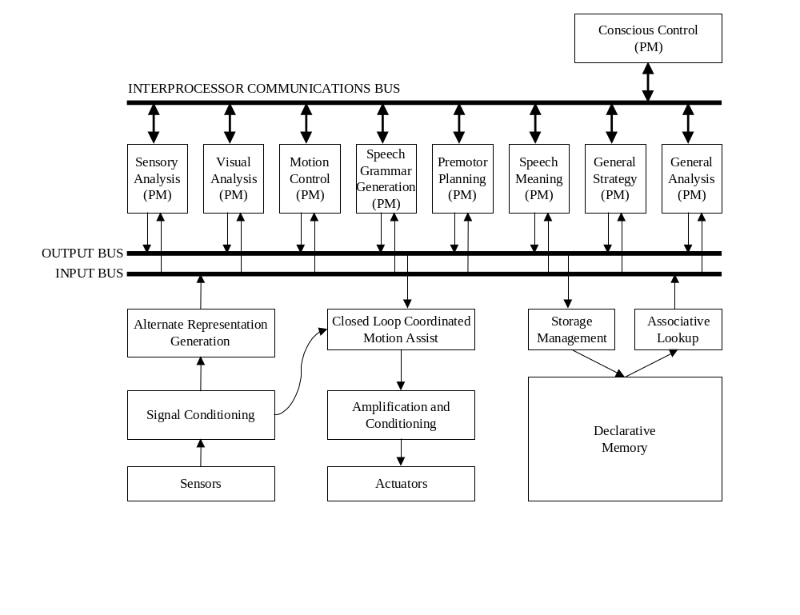
Figure 19: Comprehensive Brain Processing Model

The Brain as a Strategy Engine
The cognitive “engines” of the brain are in the cerebral cortex, which is about 4 mm thick and effectively covers the outer limits of the brain.
- The neurons in this layer are organized into cylindrical structures 0/5 mm in diameter and the full 4mm long. I’ll call each of these a Vortex. There are millions of them running in parallel.
- Typical neurons are complex logic gates with 1000 –10000 inputs.
- The different types of synaptic interconnections are reminiscent of digital steering logic. They may act as “path sensitizers,” which effectively enable one group of inputs while disabling another. In this way, a single neuron can be thought of as a large combinational circuit that can be reprogrammed for different purposes.
- The interconnects in the white matter inside the brain could represent the logical relationships necessary for applying rules and goal-checks
- By sensitizing different pathways in different neurons, various vortex processors could be hooked up to the rule and goal logic for different problems. It is likely that many Vortex processors can be hooked to the same rule and goal logic simultaneously (or possibly to different copies of the same logic).
- By running the vortex processors in parallel, and with random search and assumption strategies, a good solution to a problem is found by whatever vortex activates a goal-checker first.
Many pieces of this model are attractive. It explains:
- Why thinking sometimes seems random.
- Why brain damage to the cortex can be overcome, and why regions previously concerned with certain processing can pick up different processing
- Why older people start to think more slowly (fewer and fewer vortex processor running in parallel).
Also, this model suggests that cognitive processes are successful due to massive random search in parallel. The SRG game model can easily be implemented in hardware using digital logic, and many copies of the vortex could be synthesized to allow true parallel execution.
A synthetic version of the SRG description is easy to implement. The Situation is a traditional computer science data structure. Rules can be implemented as a combinational-logic function that accepts current Situation and generates a possible move as the next Situation. Goal-checking is similarly a combinational logic circuit.
This section examines how we can transition from the SRG representation to a game playing strategy.

The Brain as a Product of Evolution
With these postulates in mind, it is now possible to develop a view of the brain as an engine selected by evolution for specific attributes.
The storage and lookup capability of the brain is amazing, but not nearly as impressive as its analytical capacity. It is in this area that the brain far surpasses its digital impersonators.
A most interesting area of cognitive behavior is in analysis, planning, intuition, strategy, and decision making. In fact, these are at the core of “intelligent behavior.”
An analysis of the brain can benefit from consideration of the evolutionary goals placed upon it; survive. A more formal statement, in order of importance, could be:
- Stay Alive
- Reproduce
Let’s focus in on goal #1, and expand it:
- Enhance likelihood of survival
- Diminish likelihood of death
- If nothing needed at 1a or 1b, avoid conflict
This description of the cognitive process provides a very interesting insight into the question of why humans love to play games. We can restate the subgoals above as:
- Win
- Don’t Lose
- If you can do neither 1a nor 1b, Draw
This is, of course, simply human game playing behavior, and a crucial description of the essence of strategy.

The Digital Brain
An easier way to search a complex tree is to search it randomly. In this way, we hope to get lucky and stumble onto a reasonable solution. In a serial computer, this strategy is doomed to fail for non-trivial problems, since the likelihood of finding a solution is so small.
In a parallel system, however, where 100,000 vortex processors might be simultaneously performing random searches, the likelihood of finding a solution increases 100 thousandfold. Furthermore, once a single solution has been found, the number of iterations in each vortex can be limited to that solution depth and processing continued at an ever-faster rate in hopes of finding a better solution.
A game playing strategy engine can be built in the same way, with the small addition of a statistical component. Pseudo-code is as follows:
Solve A Puzzle
Set up N vortex processors for the problem at hand (BIG N)
Input initial Situation to all vortex processors
Each Vortex loops until halted
Is current Situation the goal-state? Yes; halt and shut down others
Generate random next move, based on allowable moves
Compute new Situation
Play A Game
Set up N vortex processors for the problem at hand (BIG N)
Input initial Situation to all vortex processors
Initial player is ME
Each Vortex loops until halted
Is current Situation a goal-state?
Yes; halt and accumulate win, lose, or draw for player
Generate random next move for player, based on allowable moves
If this was the first move from the initial Situation, save move as NEXT
Compute new Situation
Player = next player
After running N vortex processors for awhile…
Look at win, lose, and draw tallies for each NEXT and pick one using weights;
for example, we might choose the largest move with
WinCount + DrawCount - LoseCount

As Good As the Brain, or Better?
Most people can’t look at an 8 Puzzle and list the 24 moves, say, required to solve it without physically moving the pieces through each step and then writing them down.
This may be because the brain is memoryless, at least in terms of fast short-term storage. The brain can only iterate so many levels from the actual Situation (which is continuously re-input, usually from the optic pathways in most games.
A synthetic vortex does not have to be limited by lack of temporary, intermediate state storage.
If humans had adequate temporary situation storage, we would feel that Chess was too easy of a game, and every game between two reasonably intelligent players would result in stalemate.

Data Encoding, Part I
The two primary data structures required for processing are Actions and the Situation.
- Situation. A description of the current situation.
- Action. A description of an operation required to transition from one situation to the next. For example, a tic-tac-toe action might be, “X places a mark in row 2, column 2.”
It is tempting to represent these data types as customized data structures, or as objects in C++, say. These efforts only build elegant programs designed to play a single game, however. Since it seems unlikely that the brain has a specific tic-tac-toe hardware engine, we should adopt a more general approach.
A likely structure for a generalized strategy engine would use a generic bus for carrying the situation and action data. We can envision this bus as a parallel bus of binary digits without loss of generality.
Computer simulations can consider the bus to be a long vector of integers, where the purpose of each integer varies with the problem under solution.

What if Neural Output Isn’t Binary?
It is likely that true biological neurons do not have binary outputs, but rather have some multivalued logical output capability. We can ignore this capability, as long as we realize that we will have to use more neurons to solve a similar task, simply because the data representation will require more neurons with two-value outputs than would be required for a higher-valued logic.

The Wanderer
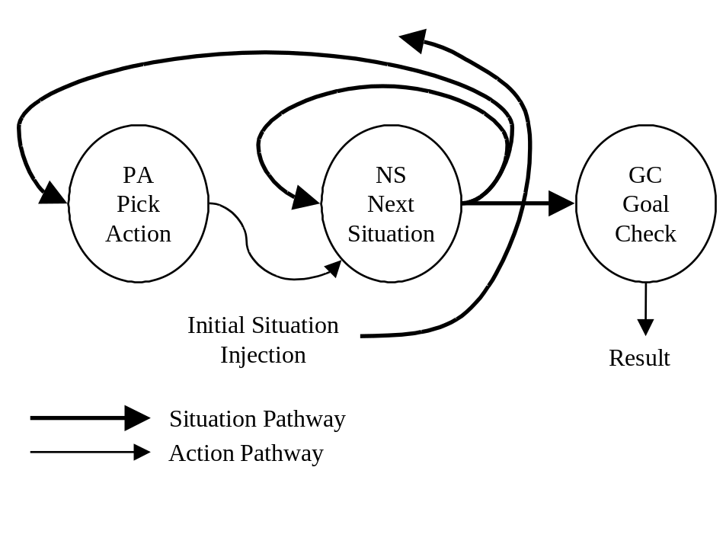
Figure 20: The Wanderer
Wanderer is a state machine that generates the next move based on the current Situation and the rules of the game. It iterates until it hits a goal, or until it runs out of time.
As a piece of traditional computing hardware, this design is quite useless. If the first action chosen, for example, is an interminable dead-end, the circuit will run forever without finding a solution. If we have 10,000 circuits running in parallel, however, there is a much larger likelihood that at least one Wanderer will find a solution.
Once a solution is found, better solutions may be searched for more efficiently. In problems that have uniform cost per step, any Wanderer still running when the first Wanderer finds its solution may be reset. Now all Wanderer may be rerun for the amount of time the first solution took to generate. This process may be repeated several times, until little progress seems to be forthcoming in reducing solution length.

8-Puzzle Wanderer Simulation
It is instructive to examine a formal Wanderer implementation in C to reveal some of the details of the technique. This coding example is included in Appendix A.
The example solves the 8-Puzzle below, which was generated by making 1,000,001 random moves from the traditional 8-Puzzle goal state.
1 | 8 | 3
 | 4 | 2
5 | 7 | 6
In the example, the situation is represented by a vector of 10 integers which represent the grid contents, followed by a redundant data element specifying the location of the blank. This redundant data item allows the move generator to find the blank without iterating through all of the puzzle tiles. This was done initially as a performance enhancement to speed the simulation, but opens up a much richer discussion on redundant data formats that we will develop later.
The action bus consists of integer pairs specifying where to move the blank from, and to. For example, moving the blank from the center to the middle of the top row is action 4,1.
Many runs of various random 8-Puzzles were run using iterations of 100,000 spinners. To reduce the results into a more understandable form, Wanderers were restricted to a number of iterations equal to the best solution found so far. In this way, poorer solutions were never reported. This modification may also be useful in practical applications of Wanderer.
A typical set of three data run for the test puzzle is shown below.
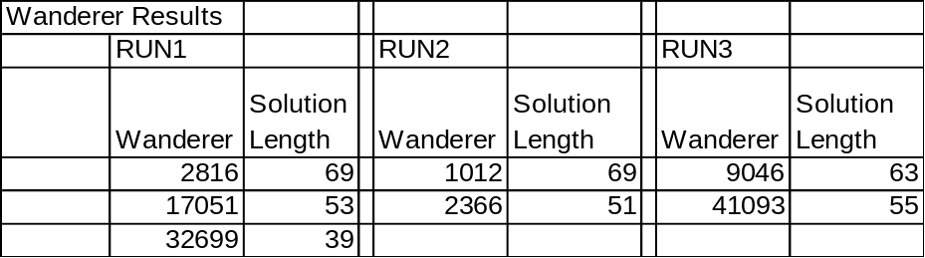
Table 1: Wanderer Results
The interpretation of these results is as follows. In Run 1, the first 2815 Wanderers found no solution. Wanderer 2816 found a solution of length 69 moves. Wanderers 2817 through 17050 found no solution better than 69. Wanderer 17051 found a solution of length 53. Finally Wanderer 32699 found a solution of length 39, and Wanderers 32700 – 99999 found no better solution than that.
These results should be considered poor for two reasons:
- 8-Puzzles rarely take more than 20 or so moves to solve
- The results are highly inconsistent, yielding solutions of length 39 to 55, after even 100,000 Wanderers have run.
A major problem with random search is regeneration of previously investigated states. This problem is well recognized and understood in the traditional AI community. Unfortunately, repeated state avoidance can be more complex than is the actual search methodology! A database of previously visited states must be kept, indexed, and maintained, activities well beyond the capability of the simple computing macrocell methodology under consideration here.
There is, however, a simple enhancement to Wanderer that drastically reduces repeated state visitation without increasing hardware. In many games, there are actions that cancel out previous actions. For example, moving the blank up one position in an 8-Puzzle, and then moving it back down to the previous position, returns the puzzle to an identical state. While many more complex cyclic move combinations are possible, their occurrence is far more unlikely than is the occurrence of simply randomly going back the way you came. By adding an exclusion capability to the random action generation step, we can avoid these immediate backtrack moves and greatly increase our search efficiency.
This is the concept of the Scout, the core macrocell concept of this entire dissertation.

Scout
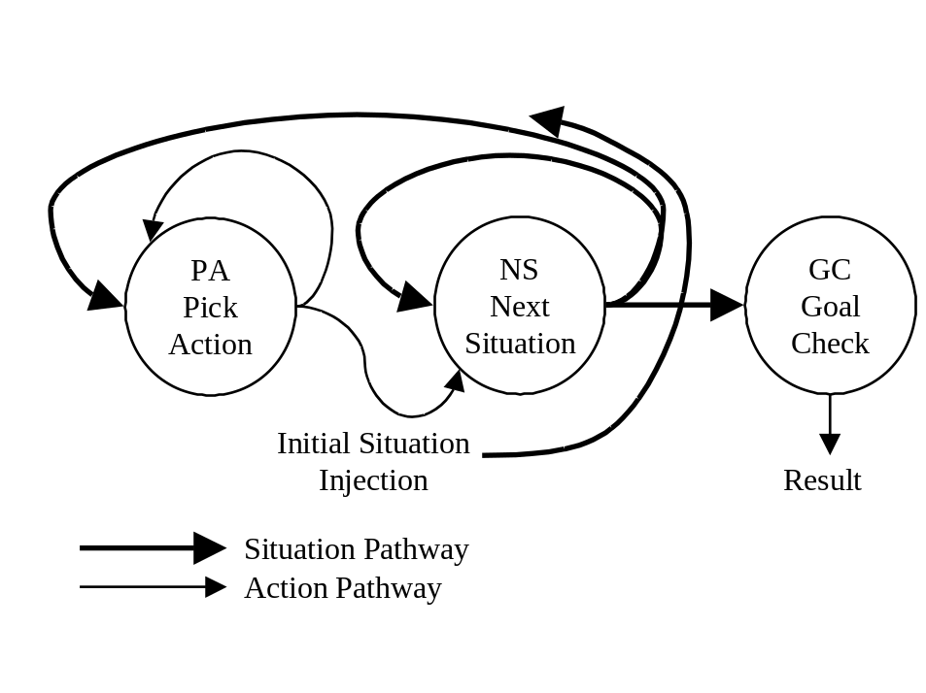
Figure 21: The Scout
The only difference between Wanderer and Scout is the addition of a feedback path from PA to itself. This represents PA having memory of the last action generated, so that it can avoid generating a backtracking move that would cancel its previous move.
This requires a little more state memory, but if we only look back one move, we vastly increase the thoroughness of the random search.

8-Puzzle Simulation
The C simulation of Wanderer may be enhanced to a Scout simulation by a simple modification of the GenerateRandomAction(…) procedure to use the previous action as a exclusion operator to prevent a direct retracing of steps to be taken. This modification is shown in Appendix B.
Many data runs were performed with Scout on 8-Puzzles. The results reported below are typical.
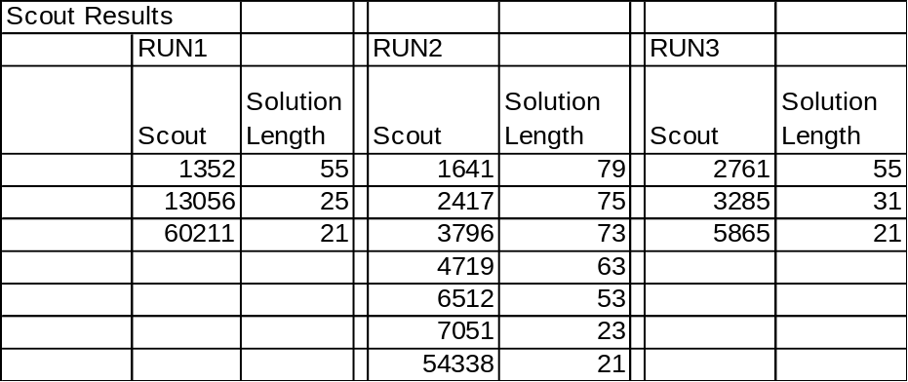
Table 2: Scout Results
In these three Scout runs, an identical solution of length 21 moves was found every time. The first run took over 60000 Scouts to achieve this solution, while the solution was found in fewer than 6000 Scouts in run 3. Many more runs duplicate the same behavior, with the Scouts finding this believed-optimal solution almost every time.
It is instructive to back away from the C simulation for a moment, since the simulation runs Scouts sequentially.
Imagine a system of 50,000 Scouts setup for 8-Puzzle solution. Since the worst-case 8-Puzzle takes less than 30 moves to solve, we could run all 50,000 Scouts for 30 moves and if no solution was found, reset them to start from scratch again. By the time we performed this reset four times, 200,000 Scouts would have searched for the solution. The preliminary simulation data says we’ll almost always have the solution by this time (the proof of this comes later in the dissertation).
In this way, our Scout network would solve arbitrary 8-Puzzles in the time it takes to generate no more than 120 random 8-Puzzle moves. If we could build the Scouts out of simple, fast hardware, total solution times on the order of 1 uS could be possible.
In the next section, a hardware architecture for Scout will be proposed that could run at 100 MHz.

Scout Hardware Implementation
A hardware block diagram of Scout is shown below. The PA (Pick Action), NS (Next Situation), and GC (Goal Check) blocks are simple combinational logic, so the only real challenge is insuring that the right states are applied to the combinational logic blocks in synchronization with one another. Effectively, we have nothing more than a recirculating state machine from classical digital electronics! Here is a sequential logic implementation.

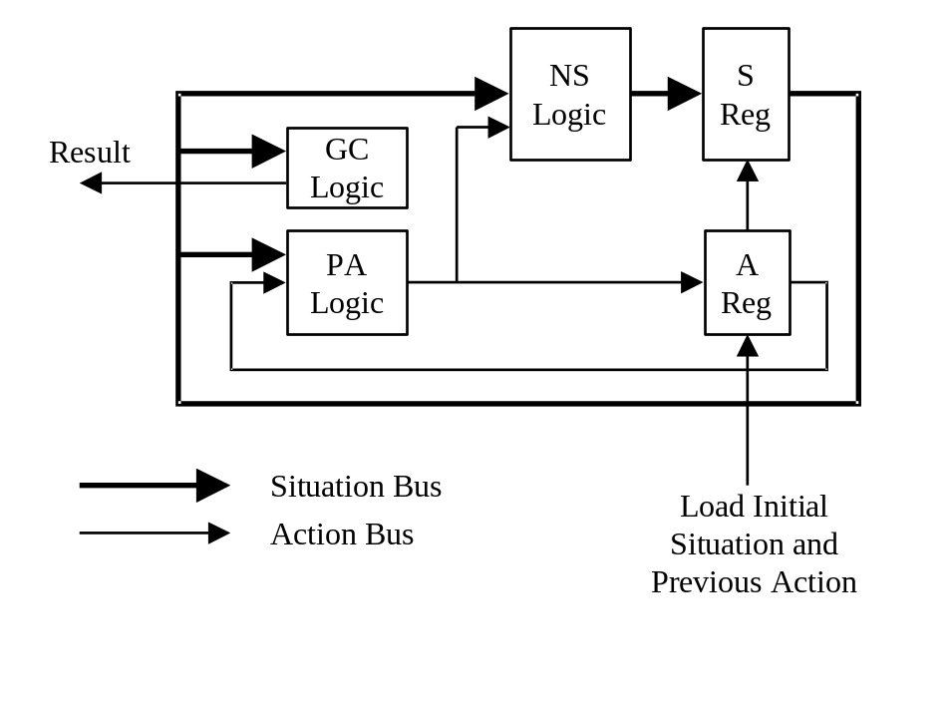
Figure 22: Scout Hardware Block Diagram
It turns out to be quite easy to implement the combinational portion of the 8-Puzzle engine in VHDL, which allows direct synthesis of a hardware curcuit using commercail CPLD devices.
[Develop actual device program]

Does the Scout Follow Neuroanatomy?
A large body of literature has been focused on human neocortex architecture. While controversy abounds, and this researcher has not yet been able to investigate directly these structures, it appears that a human has approximately 1 million cylindrical strategy processors in the neocortex. These cylinders consist of approximately 2000 neurons arranged in 0.5 mm diameter bundles 4mm think, extending from the exterior surface of the brain through all 6 layers of the neocortex, a 4mm thick sheet of neurons widely associated with visual processing, moror processing, and the development of strategy and planning. The spinner design is very appealing in that it could easily be cast into this cylindrical form, where the output axons of each included neuron are more or less fully connected to the inputs of all of the other neurons in the cylinder.
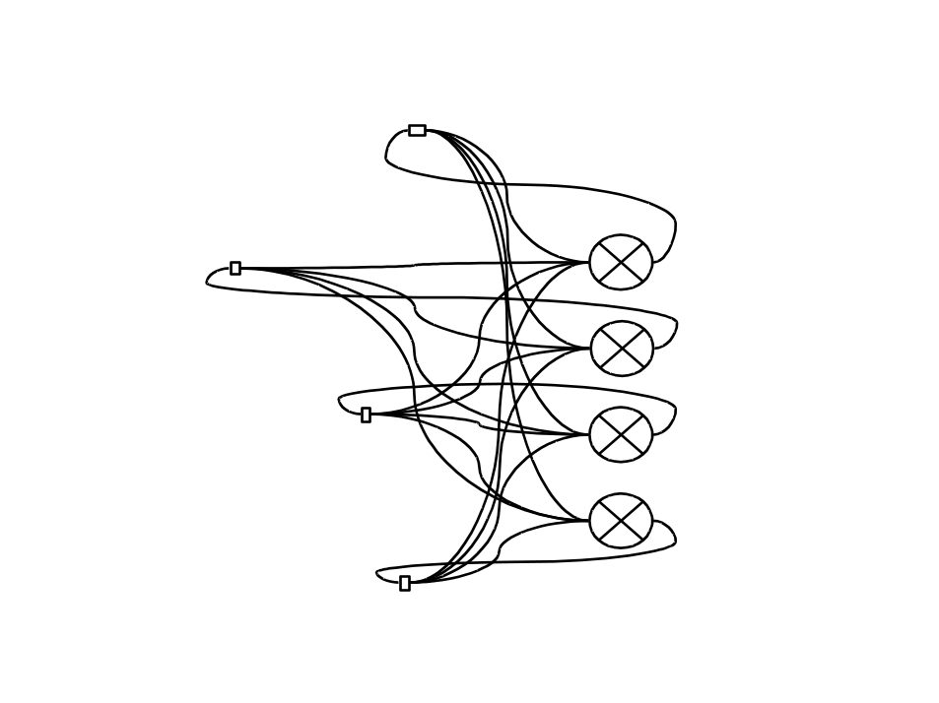
Figure 23: Scout Neural Model
If each neuron’s output can be adjusted through its input weights to be a boolean function of its inputs, then arbitrary Scout implementations could be cast a priori as neural networks, with the necessary synapse weights pre-specified by the boolean functions developed in the last section for the digtital implementation.
Unfortunately, the operation of biological neurons isn’t quite that flexible. It hs been shown, however, that a multilayer, feed-forward arrangement of neurons can be made to implement an arbitrary boolean function. Thus, by adding a few more columns of neurons to the diagram above, we can achieve Scout implementation in biological neurons.
An additional question involves what exact mechanism biology might uses for connecting the same Scout to different SRG blocks, allowing it to operate on different problems. It seems apparent that, since each neuron has up to 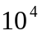 inputs, some very clever gating logic could be used, in which control signals determined which neuron inputs were actually “sensitized” at any particular time, effectively decoupling the neuron from all but the SRG blocks of interest.
There are two major pieces still missing from the archiotecture. First, is an augmentation to allow adversarial puzzles, that is, games, to be attacked. Second, and perhaps of more concern, is the lack of theoretical basis for Scout success. Given a problem, how many Scouts do I need to unleash before I have a reasonable chance of finding an acceptable solution?
This theoretical underpinning will be explored next.

A Theoretical Analysis of Scout Processing Efficiency
The Scout, as explored so far, grossly outthinks a human in solving the 8-Puzzle, since it can see the way fully and precisely to the solution, even if the solution is 25 moves ahead. Humans, lacking the high-speed, precise temporary storage of digital systems, will never match this capability.
To accept an analysis of the Scout, the concept of a unique, optimal solution must be relaxed. It is easy to get sidetracked by the search for the “optimal” solution. The problem with optimality is that, for real-world problems, the definition of optimality is so subjective that the ultimate, “optimal” solution may be ambiguous.
Instead, let’s use the term “acceptable solution.” An acceptable solution is any solution that satisfies at least one of the following criteria:
- A solution which optimizes a specific criteria (the classical definition)
- A solution which almost optimizes a specific criteria
- A solution which does not satisfy any given definition of unacceptability
It is assumed that any solution satisfying number 1 will also satisfy 2 and 3, and that any solution satisfying 2 will satisfy 3. Thus, a complete definition of acceptable solution is
Acceptable Solution: A solution which does not satisfy any given definition of unacceptability
There may be many acceptable solutions, and there may be some acceptable solutions that are more acceptable than others. For this reason, discussion will focus on the discovery of the Most Acceptable Solution.

Practical Elements of Random Number Generation
To reliably apply Scout Team processing, there must be a reasonable, predictable measure of the likelihood of finding acceptable solutions. The quality of random number generation process plays a key role in this predictability. It is, therefore, worthwhile to spend some time looking at random number generation, and the properties of random number generators.
The standard C library rand() function generates a pseudo-random sequence of integers from 0 to 32767. The probability of generating any particular number is the same, namely, 1/32767.
For the purposes of driving Scouts, it would be attractive to generate random numbers using a simple random function; ideally, one that only generates a single random bit. In so doing, it is important that the uniform frequency distribution of numbers be maintained.
A C simulation was constructed as an experimental test bed to explore these possibilities. This simulation used various techniques to generate numbers larger than 32767 from the 0-32767 rand() function in C. The simulation generated 2,000,000 random numbers between 0 and 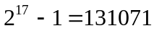, and kept histogram information on the relative frequencies of number generated. The code for this simulation, and a typical data run, are included in Appendix C. The results of the simulation are discussed below.
The first look at combining random numbers into larger random numbers was to simply sum up successive calls to rand() until the largest possible random number could conceivably be generated. For the simulation experiemtn, this required 4 calls to rand(). The relative frequencies of this experiment generate a shifted Gaussian distribution, as shown below.
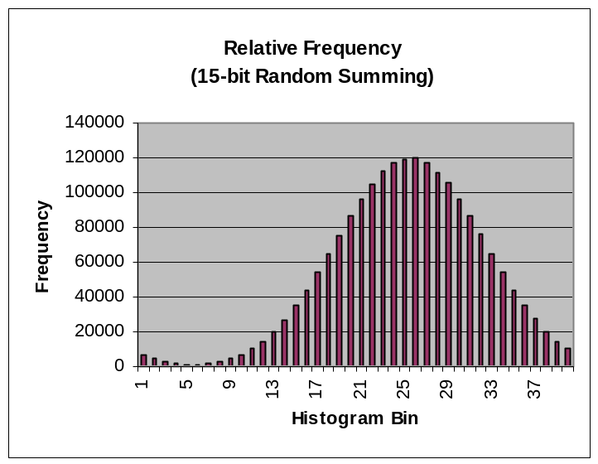
Figure 24: A Skewed Random Distribution
This result makes sense, since there are many more ways to generate four numbers that add up to a medium sum than there are ways to generate very small or very large numbers.
A more satisfying result is obtained by concatenating the 15 bit value generated by rand() onto another 15-bit rand() result. It is expected that these values, modulo the 131072 upper test limit, would be evenly distributed. They are, as shown below.
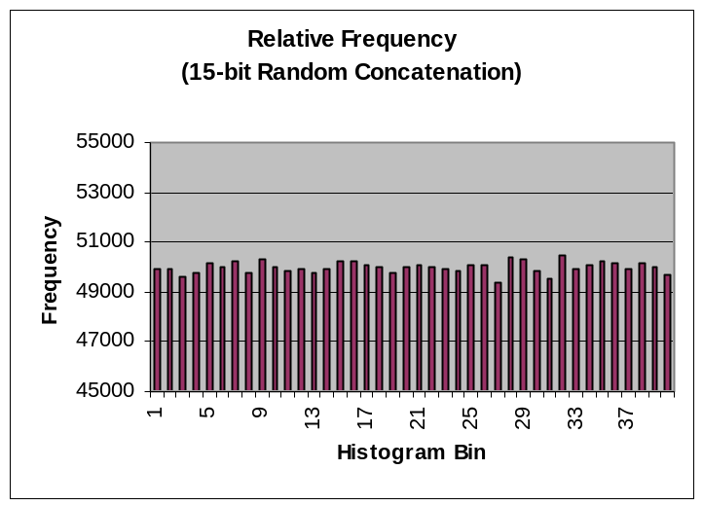
Figure 25: A Better Random Distribution
As a final test, 31-bit random numbers were constructed by concatenating the lowest bit resulting from 31 successive calls to rand(). This is equivalent to synthesizing large random numbers from a stream of individual random bits. This distribution is also extremely uniform, demonstrating the utility of such a technique.
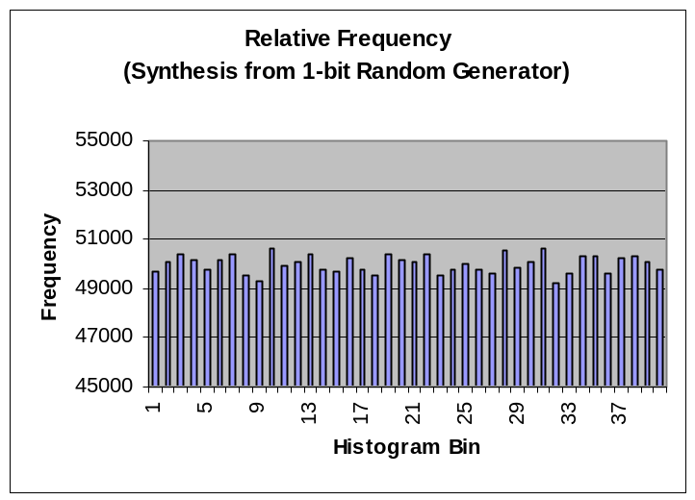
Figure 26: Large Numbers from 1 Random Bit
This methodology reduces the problem of n-bit random number generation to the simpler problem of 1-bit random number generation.

Hardware Generation of Random Numbers
Discussion of LFSR (simulation results look GREAT). Cite Bardell.
How to get non mod power2 nums from LFSR?
One idea: if num out of your sequence, gen another

Coverage Analysis
This section examines the question of how many probes are required to generate an acceptable solution to a problem. Alternatively, this can be though of as a way to determine what size goal steps are safe for a particular probe, given the number of probes available.
It is necessary that we develop the ability to determine the quality of the solutions generated by random probing. The purpose of this exploration is twofold:
- Determine whether particular solutions are likely to be acceptable
- Determine what number of probe cycles would be required to successfully attack particular problems
- Determine whether particular choices of stepped goals make solution feasible given hardware constraints
The following basic problem variables must first be defined:
d is the probe depth (number of forward simulations)
b is the average branching factor in the problem
k is the number of possible probe outcomes
n is the number of probe cycles run to depth d
is a particular probe outcome, characterized by its series of picks 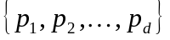
S is the set of all probe outcomes after a run 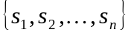
m is the number of possible final configurations of S
Recall that in probe processing, the hope is that the MAS is a member of S, since the best member of S will be delivered as our proposed solution.
The number of possible probe outcomes, k, is determined by the branching factor and solution depth of the problem.
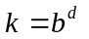
We know n probes explore n probe paths to generate n probe outcomes. Since each probe discovers one of k final situations, the total number of possible final outcomes for all n probes is:
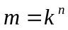
Each duplicated probe path in S is wasted effort; since investigating the same action sequence more than once tells us nothing new. Further, the order of the probe outcomes in S is unimportant, since we do not care which probe generates the acceptable solution.
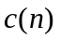 is the coverage after n probe cycles, 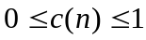
The term “coverage” will be used to describe what fraction of the possible probe outcomes is actually found in S. Ideally, we would like the coverage to be 1, since this represents complete exhaustive search and guarantees discovery of the MAS.
For example, 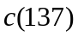 gives us the percentage of probe outcomes that have been generated after 137 probes have run.
A fundamental question of interest is “What does n need to be to generate good solutions?” The best possible solution will be found for 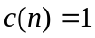, and no solution at all will be found for 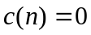. It is easy to see that 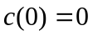 and 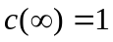, but what should n be to set to some intermediate value?
The first scout always follows one path to one unique outcome, thus:
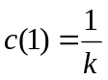
In general, if we let 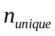 be the number of distinct paths generated by all probes so far, we have:
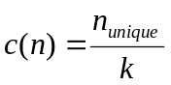
From one run to the next, will vary, since the random choices made by individual scouts will take them down different combinations of paths. However, since n is large, and expression for the average can be developed which should be useful in making accurate predictions.
This expression is built up from the probability of the coverage having each possible value:
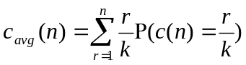
where:
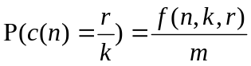
and
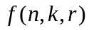 is the number of possible ways for n scouts each of which have k possible routes to investigate exactly r routes combined
In the discussion to follow, the standard notation below for the combinations of a items taken b at a time is used:
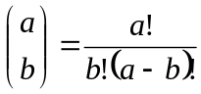
In addition, a new notation for the number of permutations of a things taken b at a time without repetition is introduced:
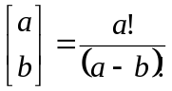
For 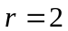, where all of the scouts follow one of 2 paths, it is fairly easy to see by direct tabulation that:
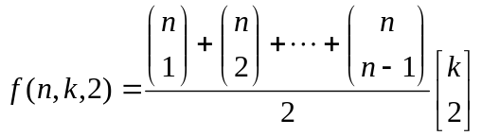
The first part of this expression describes the number of ways to partition n scouts into 2 groups; a split of 1 and n-1, a split of 2 and n-2, and so on. The second part of this expression describes how many permutations of 2 paths there are in a space containing k paths.
This partitioning of f into two pieces can always be generalized:
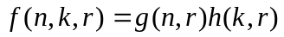
where:
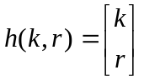
and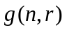has no dependency on k.
Using this new partitioning for f, a new expression for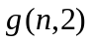can be found:
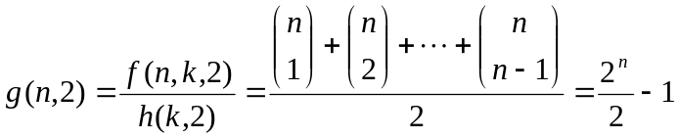
This expression is useful in generalizing the result. It says that, using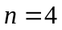as an example, there are seven different ways to partition 4 scouts into 2 groups:
Thus, the average coverage can be re-expressed as:
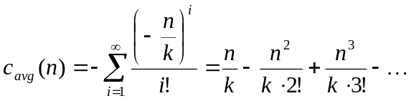
Noting that the Taylor Series expansion of 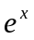is:
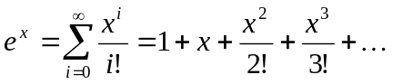
it can be seen that:
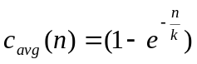

Scouting Through NP
The Scouting hardware design naturally attacks problems from NP, and is well suited for associative memory lookup and developing strategy when no algorithm exists.
[develop table showing n estimated for 15-Puzzles]
[develop stepped goal and 15-puzzle results]
[develop stream crossing from first principles and show behavior matches theory]

Scouting Enhancements for Game Play
The Scout network developed so far does not take into account opposition. This section will develop some simple extensions to the Scouting procedure that allow these “adversarial puzzles,” i.e., games, to be approached.

Contemplator
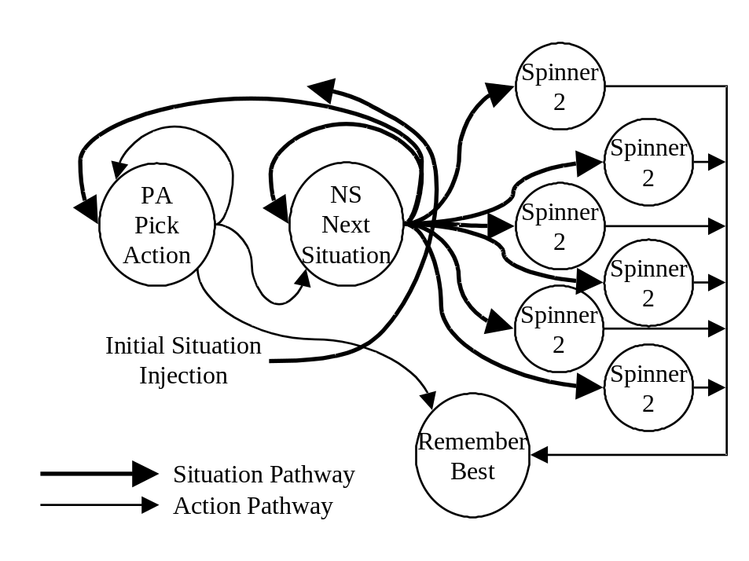
Figure 27: Contemplator
Scout can be used to simulate game play between two players with a few modifications. Effectively, we must hypothesize a move to make, and then statistically analyze our chances of winning after having made the move. Whichever possible move gives us the greatest likelihood of winning should be our choice.
More formally:
- The first simulated move from the real Situation is the TARGET move.
- Additional moves alternate between the other player and yourself. The rules and goals are the same, as long as we include the notion of WE vs. THEY.
- The simulation ends when a Win. Lose, or Draw is encountered. The result is tallied for the TARGET move.
- After simulating for as long as we like, we have Win, Lose, and Draw tallies for each TARGET. We use a linear function to decide which move is “best.”
For example, Max(Win) is the ultimate aggressive strategy. This is go for broke, and occasionally results in losses.
Min(Lose) is the ultimate defensive posture.
Max(Win-Lose) is somewhere in between.
Max(Win+Draw-Lose) says “Living to fight another day isn’t so bad.” This seems to give very human-like play in Tic-tac-toe

Tic-tac-toe Simulation
The code below shows a Spinner2 circuit used in a Contemplation loop for playing optimized Tic-tac-toe. This simulation builds in an interesting twist, allowing either systematic or random investigation of the set of available moves. In the case where move generation is expensive, the systematic approach may be more efficient.
[Need much more discussion]

Tic-tac-toe Simulation Results
The simulator easily plays to a draw, given enough simulations and enough random move generations. A simple enhancement is to allow the contemplator to systematically investigate all possible first moves, instead of randomly investigating possible first moves. This actually makes the simulator more efficient, since only first moves may actually be taken, it is useful to examine every one.

Contemplator Hardware Implementation
The following logic circuit implements the Contemplator logic. This is simply a Spinner that only feeds its next state into a parallel array of Spinner 2 circuits. The master Spinner proposes a first move, and the parallel Spinner 2s simulate randomly over and over, developing a win-lose+draw count for their simulations. The best scores for a particular first action are stored in an output register.
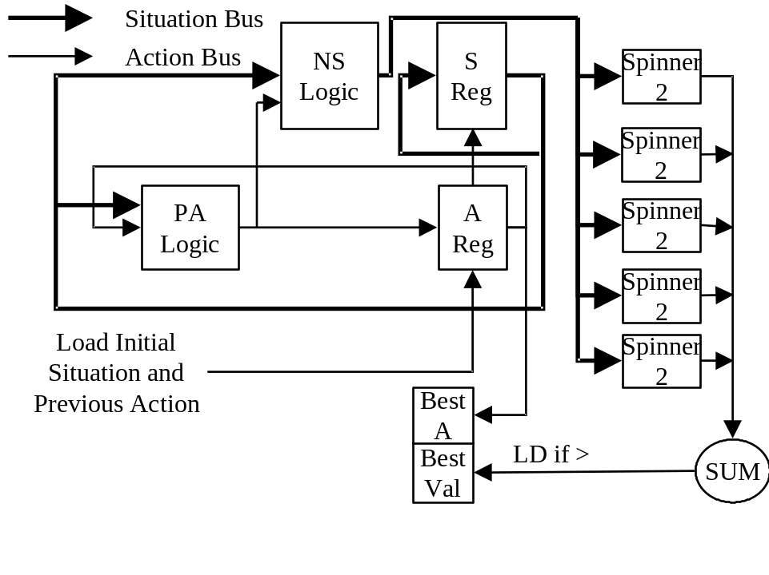
Figure 28: Contemplator Logic Design

Checkers Simulation Results
The Contemplator was used for a Checkers simulation, with much different results. Since the Contemplator bases move evaluation on number of wins, and since forward simulations of Checkers from an early state rarely generate “wins,” the simulations become lost in the complexity of the search and rarely generate any solid evidence indicating which path should be taken.
In Solver we will introduce two notions:
- Intermediate, or partial, goals
- A multiply Minimax approach used to drive move selection into a selection of move/countermove combinations, instead of just initial move picking.

Solver
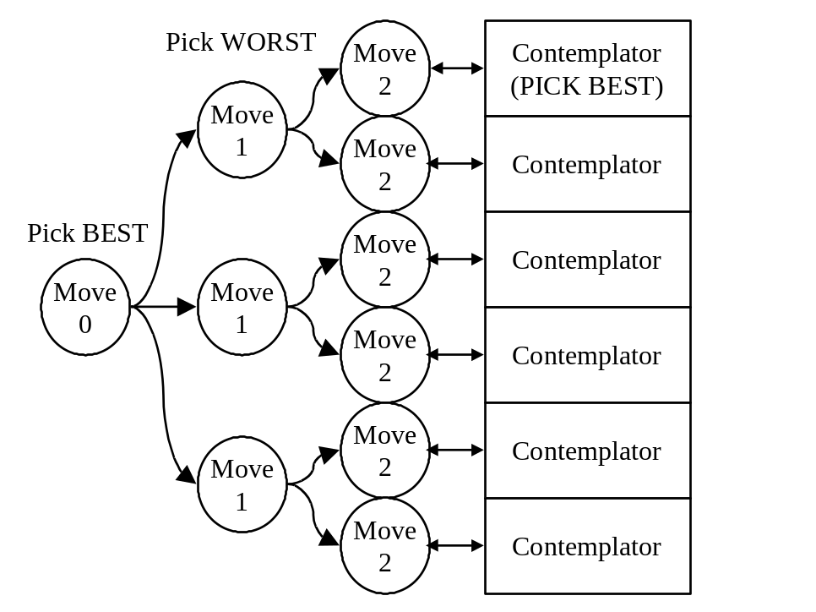
Figure 29: Solver

Intermediate Goals
Frequently, and intermediate goal or subgoal is useful in formulating a strategy. This concept is often described as “endgame” strategy. In an endgame situation, the outcome of the game has become so likely that further simulation is wasted effort. This situation is reached, for example, when one player has only a single pawn and its king, while the other player has a rook, a knight, a bishop, and their king.
These scenarios represent sure success (or failure), and as such may be thought of as goal states for the game. That is, the stated goal of the game is a concise, but incomplete, statement of the true “end of the game.”
Detecting endgame situations is complex and difficult; learning plays a greater role in this situation than in many other areas of game play.

Minimax
AI research has looked at the minimax algorithm for years as a way of enhancing computerized game play. Effectively, we choose a heuristic used to value each game situation. Then, we make the move that maximizes our own value, remembering that our opponent will make moves to minimize our value at each level.
That is, if I have three routes to win by making one move, and only two routes to win by making another, I should still take the second path if the three routes to win may all be derailed by a single move by my opponent at the next level.
The problem with minimax is usually the quality of the heuristic. It is very difficult to come up with a deterministic function that looks at two arbitrary chess boards and correctly gives relative “goodness” values for the strength of either player.
Spinner2, however, provides the ultimate heuristic; simulated game play from any position to goal states in rapid fire succession. That is, we can use Spinner 2 to build a statistical map of the likelihood of success from any game situation, and then use those statistics to drive the minimax selection.
This is the essence of Solver, which can be built up from Contemplate blocks at, say ply 3, as in the diagram.

Solver Hardware Representation
[Easy; figure not complete]

The Significance of Learning
Learning is important in humans in two major areas:
- Learning more raw information (declarative information)
- Learning how to do things (procedural information)
- Remembering the past (so we can choose to repeat it or not) (Episodic information)
Humans can become expert at specific tasks through practice and repetition. Cognitive psychologists typically require ten years of experience in a particular area before they categorize someone as an expert in this area.
An expert can be thought of as one who has taken learning on a particular topic to an extreme; therefore, experts are extreme examples of the effect of learning.
[ MORE FROM MATLIN]
Several changes are apparent in experts.

Better Data Representations
Although the results so far are very encouraging, the actual implementation of the PA, GC, and NS logic developed for our simple games requires quite sophisticated combinational logic that requires many neurons to simulate. It is possible that redundant information in the form of representing the situation in several alternate formats can reduce the complexity of this logic.
Consider that the game of checkers is represented in the simulation as a vector of 32 numbers. This vector describes a linear version of checkers, in which the pieces could be laid out in a straight line 32 positions long. Moves are represented by moving the checkers 7 or 9 positions left or right, although there are also rules about watching the linear position mod 8 to make sure you don’t move off the right edge of the board and onto the left. Similarly, jumps are represented by moves of 14 or 18 spaces left or right, as long as the position half-way between the initial position and the target position is occupied by the enemy. Of course, the same rules of not passing off one side and onto the other must be applied.
This would be an exceedingly difficult game for a human to play. The human visual cortex develops many alternate representations of vision data which contain different information useful for different purposes. This redundant data could allow two enhancements to our Contemplator:
- Simplify the combinational logic (by choosing the inputs that most easily generate each output).
- Build in an ability to “learn.”
This second item is obviously of extreme interest. By developing relationships between various data representations, it may be possible for a machine to effectively increase its own PA or GC circuitry to improve the quality of its own play.

Conclusions
usdhf

Appendix A: Scout Simulation
// Spinner Simulation
// 8 Puzzle Toy Problem

#include <stdio.h>
#include <string.h>
#include <stdlib.h>
#include <time.h>

#define TRUE -1
#define FALSE 0

// 8 Puzzle
// with blank in pos n (0-8), first el is #possible moves,
// remainder are moves
int rndMove8[][5]={
{2,1,3,0,0}, // with blank in pos 0, there are 2 moves, 1 and 3
{3,0,2,4,0}, // with blank in pos 1, there are 3 moves, 0, 2, and 4
{2,1,5,0,0}, // etc.
{3,0,4,6,0},
{4,1,3,5,7},
{3,2,4,8,0},
{2,3,7,0,0},
{3,4,6,8,0},
{2,5,7,0,0}};

// action representation
// int action[2];
// 0= move blank from position...
// 1= to

// Situation representation
// int situation[10];
// position map 0 1 2
// 3 4 5
// 6 7 8
// 9 is redundant location of blank

// the test puzzle
int initialSituation[]={
// 1 8 3
// 0 4 2
// 5 7 6 with blank in pos 3
1,8,3,0,4,2,5,7,6,
3};

// desired goal
int goalSituation[]={
// 1 2 3
// 8 0 4
// 7 6 5 with blank in pos 4
1,2,3,8,0,4,7,6,5,
4};

// display a game situation
void ShowSituation(int* situation)
{
printf(" ---\n");
for(int i=0; i<3; i++)
{
char buf[28];
buf[3]=0;
for(int j=0; j<3; j++)
buf[j]='0'+situation[i*3+j];
printf("|%s|\n",buf);
}
printf(" --%1d\n\n",situation[9]); // shows redundant blank pointer
}

// Is situation in the goal state?
int GoalCheck(int* situation)
{
return 0==memcmp(situation,goalSituation,9*sizeof(int));
}

// Given the current situation, pick a random action
void GenerateRandomAction(int* action,int* situation)
{
// pick a random move using the possible move table
int blankPos=situation[9];
int n=rndMove8[blankPos][0];
int move=rndMove8[blankPos][rand()%n+1];

// build action = from,to
action[0]=blankPos;
action[1]=move;
}

// perform 'action' on 'situation'
void ComputeNewSituation(int* situation, int* action)
{
int from=action[0];
int to=action[1];

situation[from]=situation[to]; // move the blank
situation[to]=0;
situation[9]=to; // update redundant position
}

// Spinner Implementation
// return depth of found solution or -1 if no solution found
int Spinner(int* initialSituation,int maxIterations)
{
int situation[10];
memcpy(situation,initialSituation,10*sizeof(int));

int action[2];
action[0]=-1; // invalid initial action to be ignored

int iterations=0;

while(!GoalCheck(situation) && iterations<maxIterations)
{
GenerateRandomAction(action,situation);
ComputeNewSituation(situation,action);
iterations++;
}

if(iterations<maxIterations)
return iterations;
else
return -1;
}

int main()
{
ShowSituation(initialSituation);

int best=100;

// run 100000 spinners
srand(time(NULL));
for(int i=0; i<100000; i++)
{
int d=Spinner(initialSituation,best);
if(d>0 && d<best)
{
printf("Found solution spinner %d, depth=%d\n",
i,d);
best=d;
}
}

return 0;
}

Appendix B: The Scout Enhancement
// Given the current situation, pick a random action
// This is the Spinner2 Version, which avoids direct backtracks
void GenerateRandomAction(int* action,int* situation)
{
int blankPos=situation[9];
int lastBlankPos=action[0];

// keep picking random moves until we aren't backtracking
int move=lastBlankPos;
while(move==lastBlankPos)
{
int n=rndMove8[blankPos][0];
move=rndMove8[blankPos][rand()%n+1];
}

// build action = from,to
action[0]=blankPos;
action[1]=move;
}

Appendix C: Scout War
#include <stdio.h>
#include <string.h>
#include <stdlib.h>
#include <time.h>
#include <conio.h>

//#include <sys/types.h>
//#include <sys/timeb.h>

#define TRUE -1
#define FALSE 0

const int EMPTY=0;
const int X=1;
const int O=2;

const int WIN=1;
const int LOSE=2;
const int DRAW=3;
const int INDETERMINATE=4;

// TicTacToe

int* InitialSituation(void)
{
static int isit[]={0,0,0,0,0,0,0,0,0};

return isit;
}

void ShowSituation(int* s)
{
printf(" ---\n");
for(int i=0; i<3; i++)
printf("|%1d%1d%1d|\n",s[i*3],s[i*3+1],s[i*3+2]);
printf(" ---\n\n");
}

int win[][3]={
{0,1,2},
{3,4,5},
{6,7,8},
{0,3,6},
{1,4,7},
{2,5,8},
{0,4,8},
{2,4,6}};

int GoalCheck(int* s)
{
for(int i=0; i<8; i++)
{
int player=s[win[i][0]];
if(player)
if(player==s[win[i][1]] &&
player==s[win[i][2]])
return player;
}
for(i=0; i<9; i++)
if(s[i]==EMPTY) return INDETERMINATE;

return DRAW;
}

void GenerateFirstSystematicAction(int* action,int* situation,int player)
{
for(int i=0; i<9; i++)
if(situation[i]==EMPTY)
{
action[0]=player;
action[1]=i;
return;
}
// no first action
action[0]=0;
action[1]=0;
}

void GenerateNextSystematicAction(int* action,int* situation)
{
int player=action[0];
int pos=action[1];
for(int i=pos+1; i<9; i++)
if(situation[i]==EMPTY)
{
action[1]=i;
return;
}

// no next action
action[0]=action[1]=0;
}

void GenerateRandomAction(int* action,int* situation,int player)
{
int it=0;
while(it++<200)
{
int i=rand()%9;
if(situation[i]==EMPTY)
{
action[0]=player;
action[1]=i;
return;
}
}
// this should never happen
printf("SOMETHING'S WRONG. Seems to be no move!\n");
}

void ComputeNewSituation(int* situation, int* action)
{
situation[action[1]]=action[0];
}

int Spinner2(int* initialSituation,int maxIterations,int player)
{
int situation[9];
memcpy(situation,initialSituation,9*sizeof(int));

int action[2];
action[0]=action[1]=0;

int iterations=0;

int g=GoalCheck(situation);
while(g==INDETERMINATE && iterations<maxIterations)
{
GenerateRandomAction(action,situation,player);
ComputeNewSituation(situation,action);
g=GoalCheck(situation);
//ShowSituation(situation);
//getch();
player = player==X ? O:X;
iterations++;
}

return g;
}

// Try playing 'player' from here. firstMoves=-1 is exhaustive, else
// number of random ones to try. simulations is games per
// first move
int* Contemplate(int* s,int player,int firstMoves,int simulations)
{
int oplayer = player==X?O:X;

static int bestAction[2];
int bestSignal=-9999;

int moreFirstMoves=TRUE;
int moveCounter=0;
int movePos=0;
while(moreFirstMoves)
{
int situation[9];
memcpy(situation,s,9*sizeof(int));
int action[2];

if(firstMoves<0)
{
if(moveCounter==0)
GenerateFirstSystematicAction(action,
situation,player);
else
GenerateNextSystematicAction(action,situation);
if(action[0]==0)
{
moreFirstMoves=FALSE;
break;
}
}
else
{
GenerateRandomAction(action,situation,player);
if(moveCounter>firstMoves) moreFirstMoves=FALSE;
}

ComputeNewSituation(situation,action);
moveCounter++;

int nWin=0;
int nLose=0;
int nDraw=0;
for(int j=0; j<simulations; j++)
{
int g=Spinner2(situation,8,oplayer);
if(g==player) nWin++;
else if(g==oplayer) nLose++;
else if(g==DRAW) nDraw++;

}
int signal=nWin+nDraw-nLose;
if(signal>bestSignal)
{
bestSignal=signal;
memcpy(bestAction,action,2*sizeof(int));
}
}

return bestAction;
}

int main()
{
ShowSituation(InitialSituation());

int depth=100;
int player=X;
int situation[9];

int nWin=0;
int nLose=0;
int nDraw=0;

int intelligence[3];
intelligence[X]=40;
intelligence[O]=400;

int firstMoves[3];
firstMoves[X]=-1;
firstMoves[O]=-1;

for(int i=0; i<50; i++)
{
if(!(i%10000))
{
unsigned int t=time(NULL);
srand(t);
printf("reseeded(%u)\n",t);
}

memcpy(situation,InitialSituation(),9*sizeof(int));
int noWin=TRUE;
while(noWin)
{
int* action=Contemplate(situation,player,
firstMoves[player],intelligence[player]);
ComputeNewSituation(situation,action);
//ShowSituation(situation); getch();
int g=GoalCheck(situation);
if(g==INDETERMINATE)
player=player==X?O:X;
else
{
noWin=FALSE;
printf("Game Over! %d\n",g);
if(g==WIN) nWin++;
if(g==LOSE) nLose++;
if(g==DRAW) nDraw++;
}

}
}

printf("Result: W=%d L=%d D=%d\n",nWin,nLose,nDraw);
return 0;
}

Appendix C: Random Number Synthesis

Simulator Program
// J.E. (Ned) Lecky
// Qualification of Random number generator
#include <stdio.h>
#include <stdlib.h>
#include <memory.h>
#include <math.h>

// VRand correctly generates random numbers 0-(maxRand-1) for maxRand up
// to 2^31. This routine is importand since the library rand() function
// only generates random integers up through 2^15
int VRand(int maxRand)
{
int r=rand() | (rand()<<15) | ((rand()&1)<<30);

return r%maxRand;
}

// BadRand illustrates how NOT to generate random numbers from several
// random numbers
int BadRand(int maxRand)
{
int nSums=maxRand/RAND_MAX+1;

int r=0;
for(int i=0; i<nSums; i++) r+=rand();

return r%maxRand;
}

// UniRand synthesizes a 31-bit random number from 31 calls to rand()&1.
// This is a test of our ability to generate large random numbers from
// a single random bit generator
int UniRand(int maxRand)
{
int nBits=31;
int r=0;
for(int b=0; b<nBits; b++)
r |= (rand()&1) << b;

return r%maxRand;
}

//
const int nBins=40; // number of histogram bins
const int nRands=2000000; // how many rand()s to generate
const int maxRand=131072; // rands range from 0 to maxRand-1
int main()
{
int* bins=new int[nBins];

for(int r=0; r<3; r++)
{
// reset random generator and clear hist bins
srand(0);
memset(bins,0,nBins*sizeof(int));
int binSize=maxRand/nBins;

// generate nRands random number
for(int i=0; i<nRands; i++)
{
int rand=0;
switch(r)
{
case 0:
rand=BadRand(maxRand); break;
case 1:
rand=VRand(maxRand); break;
case 2:
rand=UniRand(maxRand); break;
}

// increment corresponding histogram bin
int bin=rand/binSize;
bins[bin]++;
}

// display results
for(i=0; i<nBins; i++)
printf("%d %d\n",i,bins[i]);
}

delete bins;
return 0;
}

Example Data Run
(Summing Random Numbers)
0 6847
1 4333
2 2632
3 1672
4 1047
5 1154
6 1633
7 2735
8 4380
9 6745
10 10144
11 14619
12 20109
13 27137
14 35216
15 44201
16 54004
17 65184
18 75477
19 86338
20 96275
21 104909
22 111944
23 116999
24 119292
25 120029
26 117005
27 111896
28 105582
29 96627
30 86643
31 76201
32 65104
33 54228
34 44145
35 35159
36 27283
37 20231
38 14539
39 10228
(Concatenating Random Numbers)
0 49891
1 49908
2 49622
3 49789
4 50129
5 50032
6 50206
7 49800
8 50310
9 49983
10 49863
11 49889
12 49799
13 49957
14 50273
15 50242
16 50103
17 50020
18 49734
19 50037
20 50086
21 49981
22 49911
23 49827
24 50056
25 50099
26 49369
27 50426
28 50280
29 49863
30 49535
31 50478
32 49917
33 50040
34 50244
35 50142
36 49900
37 50190
38 49968
39 49649
(Concatenating single random bits)
0 49663
1 50108
2 50363
3 50148
4 49727
5 50168
6 50357
7 49540
8 49299
9 50608
10 49938
11 50043
12 50404
13 49799
14 49683
15 50211
16 49799
17 49513
18 50372
19 50164
20 50043
21 50374
22 49561
23 49755
24 50009
25 49796
26 49643
27 50518
28 49861
29 50089
30 50627
31 49194
32 49611
33 50343
34 50280
35 49632
36 50205
37 50332
38 50074
39 49752

Bibliography
Much of the anatomical and physiological information in this dissertation comes from Gray’s Anatomy, 38th Edition (1995), published by Churchill Livingstone, and edited by Bannister, Berry, Collins, Dussek, Dyson, Ellis, Gabella, Salmons, Soames, and Standring.. This is really THE authority and state-of-knowledge on human anatomy.
Other References:
Allport, Susan (1986). Explorers of the Black Box. W.W. Norton & Co.
Bardell, Paul, McAnney, William H., and Savir, Jacob (1987). Built-In Test for VLSI: Pseudorandom Techniques. John Wiley and Sons
Cairns-Smith, A. G. (1996). Evolving the Mind. Cambridge University Press.
Caudill, Maureen and Butler, Charles (1990). Naturally Intelligent Systems. MIT Press.
De Becker, Gavin (1997). The Gift of Fear. Little, Brown, and Co.
Greenfield, Susan A. (1997). The Human Brain. Harper Collins.
Matlin, Margaret W. (1998). Cognition, 4th Edition. Harcourt Brace.
Polivka, Raymond P. and Pakin, Sandra (1975). APL: The Language and Its Usage. Prentice-Hall.
Russell, Stuart and Norvig, Peter (1995). Artificial Intelligence. Prentice Hall.
Sedgewick, Robert (1990). Algorithms in C. Addison-Wesley.
Squire, Larry R. (1987). Memory and Brain. Oxford University Press.

Polivka (1975), p. 90
Sedgewick (1990), p. 4
Sedgewick (1990), p. 529
Sedgewick (1990), p. 634
Sedgewick (1990), p. 635
Sedgewick (1990), p. 639
As quoted by Allport (1986), p. 47
Baars, B.J. A Cognitive Theory of Consciousness, quoted by Cairns-Smith (1996), p. 99
Cairns-Smith (1996), p. 113
Several articles in Scientific American, 1987 – 1992, cited by Cairns-Smith (1996).
Allport (1986), p. 57
Allport (1986), p. 164
As quoted by Allport (1986), p. 168
Paraphrase of Allport (1986), p. 169
Cairns-Smith (1996), p. 55
R. Wrangham and D. Peterson, Demonic Males, as quoted by DeBecker (1997), p.43
Humans have been engaged (sporadically) in intellectual pursuits since around the time of the ancient Egyptians, ca. 4000 BC. Human evolution didn’t really start until the mammals really got rolling post-dinosauria, 65 million years ago. Thus, we’ve only gotten intellectual in the last 0.009% of our development.
As noted by Cairns-Smith (1996), p. 122
When looking at such figures, one always has to wonder at the power of olfactory processing as a replacement for intelligence. Lower animals are such tremendously effective predators as a result of more highly developed olfactory capacity. In humans, olfactory capacity is almost non-existent, however, we are the most effective, deadly, and successful predators of all time.
Greenfield (1997), p. 14-15
Gray’s Anatomy (1995), p. 1342-3
The author has not verified that 21 is the optimal solution, but hundreds of runs have found no better solution.

